DLUHC Research

Aggregator user research, January 26 2022

Summary
Blackburn with Darwen (BwD), working in partnership, have been provided funding to facilitate an investigation/ undertake research and develop recommendations with local Voluntary, Community, and Faith Sector (VCFS) organisations. BwD should focus on the organisations within their region only when conducting their research.

BwD needs to provide a breakdown of the different types of inputs that will be going into the Aggregator i.e. how many organisations are providing their information by CSV, API or manually.

BwD need to establish what differences there are between the CSV's and whether or not they are broadly standardised to enable easy adherence to the Open Referral standard. The Digital Team will undertake the above user research and prepare a report on Findings by January 2023. The Digital Team has been chosen due to their understanding of the local digital agenda and specifically their drive to adopt Data Standards generally and Open Referral UK.

What we did
We carried out user research with 29 organisations based in BwD, we identified a number of key issues with engagement. For those organisations that couldn’t / wouldn’t participate this was mainly because of their capacity to assist us. This is due to post pandemic, cost of living crisis and winter pressures. We asked a series of questions that related to data storage methods on service information and the ways that they promote service offers. This helped us to understand the capabilities and capacity to work with BwD in the potential development of an Aggregator.

Key findings
The research shows that due to capacity and service pressures keeping service information up to date cannot always be a priority. The participants shared their experiences of the tools and methods that they currently use, this highlighted the limited use of structured or semi structured data in relation to their services. Organisations currently use various tools and processes which differ depending on their digital capabilities.

Our research highlighted that organisations are not aware of Open Referral UK Standards which may be a contributing factor to why they do not currently have consistent methods in sharing or collating information. Training needs would need to be adapted to meet specific and varied skill gaps as not all organisations have the skill set to be able to standardise information and confidently use a digital tool. Participants have a
willingness to work with BwD to support the development of improvements in accessible information across BwD. This would require training and support as well as regular reminders to ensure that information is kept up to date. It was identified that organisations would prefer to only provide high-level information about their services as this would be less resource intensive.

Next steps
This research has given us an understanding of capacity, capability and motivation within the VCFS.

With this information we can develop effective partnership plans for the provision of digital information on services for residents – a single source of up to date and assured information available on digital platforms. Next steps include collaboration and sharing information with other Local Authorities such as Greenwich and Leeds and to consider alignment with Place based Integrated Care Board developments, and local initiatives such as plans for digital inclusion.

Access to information for residents is also an important part of the development of family hubs and Care Quality Commission regulation and inspection.

The findings of the research will be presented to BwDBC Senior Leadership Team, with recommendations based on the options highlighted in this report.

These recommendations are likely to include an outline of key milestones such as the development of a vision and project plan, training and support for VCFS partners, alliances with partners including DLUHC and local authorities, and a timetable for an incremental project plan.

Evaluating the experience of our VCFS organisations

User feedback on aggregator research

Background

We have carried out user research to look at how local VCFS organisations store and share information on their services and the format that it is stored, to understand if they are broadly standardised to enable easy adherence to the Open Referral UK standards.

Purpose and Scope

This purpose of this study is to evaluate the current processes and behaviours around how our VCFS organisations store and share information on their service offer, specifically:
- A breakdown of the different types of inputs that will be going into the Aggregator i.e. how many organisations are providing their information by CSV, API or manually.
- Establishing what differences there are between the CSVs and whether or not they are broadly standardised to enable easy adherence to the Open Referral standard.

Method

The VCFS organisations answered a series of set questions to prompt their feedback on how they currently store and share information and their ability to input service information into an Aggregator.

Research engagement

Our engagement target is to conduct user research with 30 organisations. We contacted 50 users to participate in this research. We reached out to a wide range of people to make sure that all sizes and makeup of the organisations were represented in the research.

We have successfully engaged with 29 organisations who agreed to participate. For those organisaions that couldn’t / wouldn’t participate this was mainly because of capacity to assist us. This is due to post pandemic, cost of living crisis and winter pressures. We identified that on some occasions meetings were cancelled or rescheduled due to:

- Sickness
- Staffing
- Resource and priorities
- Service delivery priorities

Organisations we engaged with

- 2 National organisations
- 5 Regional organisations
- 22 Local organisations

We engaged with both volunteer led organisations and larger organisations with paid staff and the split of these can be seen below.
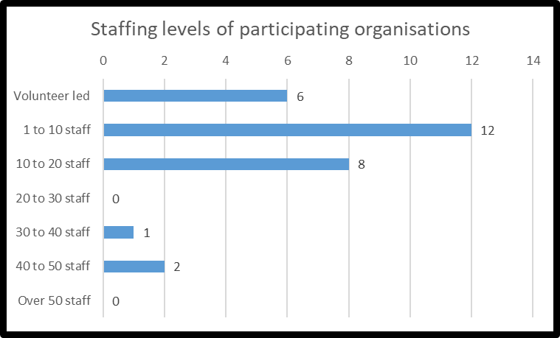

Support delivered by organisations

We engaged with organisations that offer a range of services, activities and support for local residents reaching different demographics across Blackburn with Darwen. Some offer specific support for example, support for children and young people and others have a wide ranging offer of support such as volunteering opportunities, housing advice and disability support. The visual on the following page outlines services and support for residents across Blackburn with Darwen.

We tried to engage with all service areas delivered by VCFS organisations that are available to residents across Blackburn with Darwen.

The majority of organisations offered support for:

- Vulnerable and isolated adults
- Residents from BAME communities
- Promoting and encouraging Health and Wellbeing
- Residents with disabilities including children

Engagement insights

- Organisations were identified at the start of the project and all 50 contacted.
- Some organisations required additional meetings as the participant was not always aware of the storage methods or practices varied across the team.
- Organisations were keen to engage with us however resource and pressures could not always accommodate this.
- Organisations are still trying to recruit for vacant paid and volunteer positions following on from COVID. This has added extra pressures.
- Some organisations required additional meetings with multiple staff as information storage practices varied dependant on staff member responsibilities.

Summary of support offered
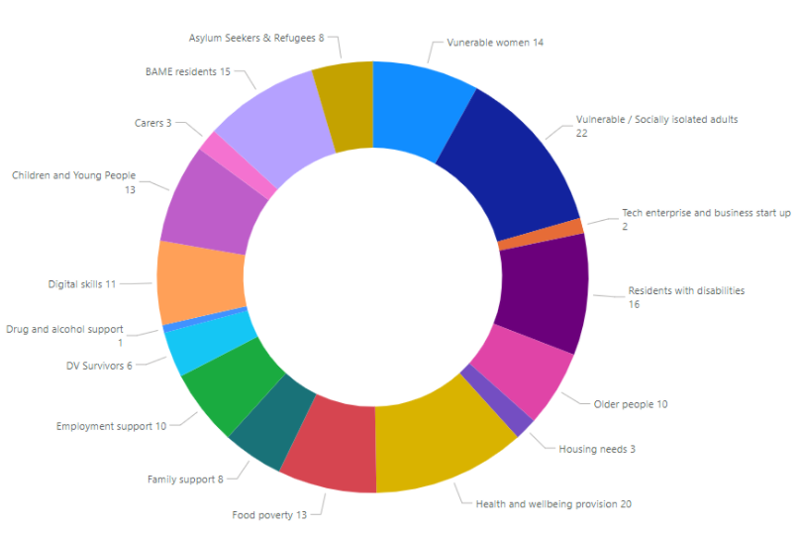

Current storage methods used

A breakdown of the different types of inputs that will be going into the Aggregator i.e. how many organisations are providing their information by CSV, API or manually.

As part of this research we identified the current most popular storage methods used, these are the methods and platforms that organisations would prioritise keeping service information up to date.

Research insights

Organisations do not currently have a structured approach to the way that they store information on their services. We identified that they have access to computers to help them create and manage service information however the preferred methods varies depending on the organisations digital capabilities and confidence.

- Paper based methods seems to be the most popular across organisations, even those with digital systems in place, this includes materials such as printed activity timetables, posters, paper diaries and signing in sheets. These are usually stored in filing cabinets.
- Cloud based storage systems including Microsoft share point sites and google drive to store documentations related to service provision. Saved documents include images, word documents, designed printable posters and leaflets.
- Server drives serve the same purpose as the cloud based storage sub folders, this is the preferred method of storage for 5 organisations. However these organisations aim to move to cloud based storage systems in the future.
- 2 Organisations have a dedicated system or data base that is used to store information these data bases are managed by specific staff members, As part of the research we identified 1 of the systems was a national system that is used as part of monitoring and identifying available refuge spaces and support available for users who are experiencing domestic violence. The other system used by 1 of the organisations is called Zoho data based managed software and this organisation have a dedicated officer to support the build and management of the data base.
- Trello is the preferred method used by 2 organisations, the primary function is to communicate across the team and update on service delivery including photographs from events, posters for provision, any changes to time and date of sessions and as a creative space to explore new ideas.
- Websites are the most up to date for many of the organisations and this is used to keep service information up to date.
Some organisations have dedicated staff that help manage the storage of information and others will share the role dependent on capacity across the team. All organisations do not currently store and share information in a consistent format that would adhere to Open Referral UK standards. Although we have identified the preferred method of storage for organisations there are other methods used these include:

- Saving word documents on a desktop
- Outlook email sub folders
- Outlook calendars

Information sharing methods

Organisations share information in many different ways to a variety of stakeholders and service users. The below visual outlines the most popular methods that organisations use. This is not limited to 1 type of sharing method per organisation.

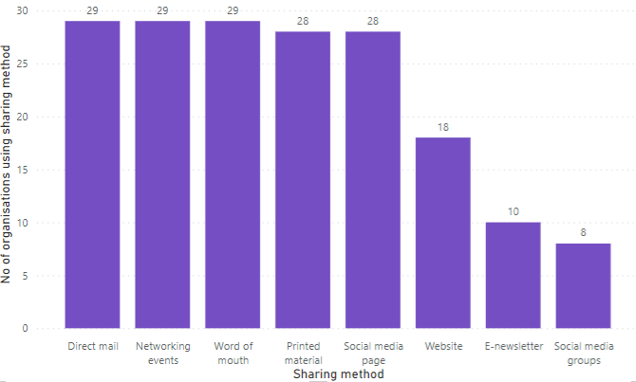

Research insights on sharing methods
The larger organisations that have dedicated officers to manage the promotion of services have the resource and skill set to create and update content for web based platforms such as websites, social media and e- newsletters whereas the smaller organisations rely more on word of mouth, networking events and printed leaflets and posters to promote services..

- All organisations use Direct mail, Networking events and Word of mouth as methods to share information with others on their services. An example of using direct mail is a member of staff from 1 organisation emailing posters to be included in another organisations newsletter or a direct mail out to users of the service.
- 28 organisations use Printed materials to promote services this includes promotional material such as posters, leaflets, information sheets and referral forms.
- Social media pages are used to promote services to a wider audience including residents, stakeholders and other agencies. Social media platforms used are Facebook, Instagram, Tiktok, Twitter and LinkedIn. As part of the research we identified that not all organisations are on all platforms.
- 18 of the organisations use their Websites as a promotional tool.
- E news letters are developed by 10 organisations predominantly those with marketing staff, these include specific service information for example dates, times and session information.
- Social media groups are used to interact with and provide updates to service users, organisations feel that this is an effective way of sharing information and engaging with users of the service as it’s also a tool to communicate through as well as identifying how many people will be attending an event.

Would organisations be willing to get involved with improving how information is shared?

Quotes from organisations:
- “Yes I personally think it’s good we need to promote our service in a better format”
- “Yes would be willing to get involved - however this depends on time and resource within the organisation”
- “Yes within reason if there were clear benefits and this wasn’t too onerous - happy to share service outline what the offer is and the locality rather than specifics (such as time, date and direct location)”
- “Yes definitely”
- “Yes…As long as it does not give any more work
- “Yes depending on time and commitment needed”
- “Yes however resource and capacity is a huge issue”
- “Yes, as long as it didn’t demand too much time! Service Finder has taken a lot of staff time and involvement and it started to feel like a big time investment into something that I’m not convinced is ever used”
- “If it reaches the communities we need it to reach. The communities we work with traditional methods work best - e.g. word of mouth, door knocking and leaflets. We already exceeded participation and engagement targets on all our projects - we would get in the spirit of partnership wor”
- “Yes moving forward we would look to do this and update information - capacity dependent”
- “I want something that makes it easier to continue and develop what we offer”
- “Tes would prefer a reminder with a spreadsheet to update information. We don’t need to advertise”
- “Yes”
- “Yes absolutely. Would prefer a web portal and to be notified once every 6 months to prompt us to update service information”
- “Yes 100% definitely. In terms of service information we are happy with most formats to update information”
- “Yes to help get more people to the sessions, the process needs to be simple and have to be reminded”
- “Updates as and when needed not regular updates so would provide overview of the overall offer that way wouldn’t be resource intensive”
- “Only a small team of volunteers so if it was easy and we had the time then we would. Would be able to email updates if reminded”
- “Yes happy to email information over - limited time and digital skills”
- “Yes only if we can email information”
- “If we had time and volunteers to do this. We would love too but capacity may be an issue as it is minimal”
- “Absolutely training would be required we would need a reminder to update information”
- “Yes this would depend on capacity as we are a small team of volunteers”
- “No we need to be careful where we promote our services as we may not be able to manage the demand”
- “Yes if this was a quick task and not consuming as we do not have funding for full time paid staff”
- “Yes as long as this is simple as we already share on face book”
- “No as we don’t provide direct services we enhance other organisation provision”
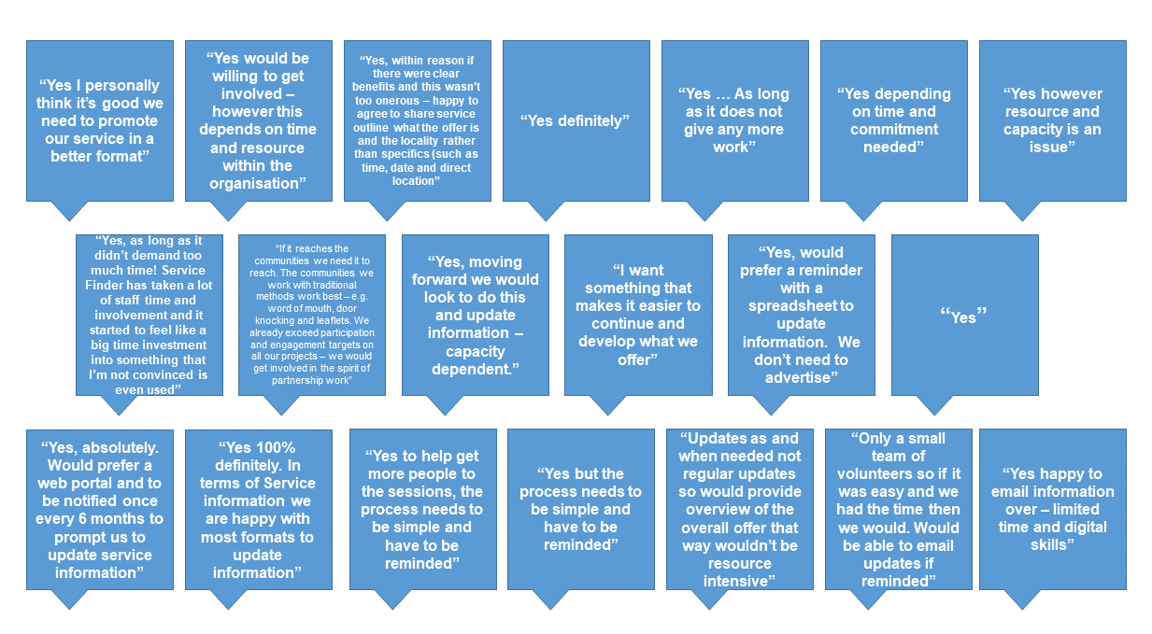
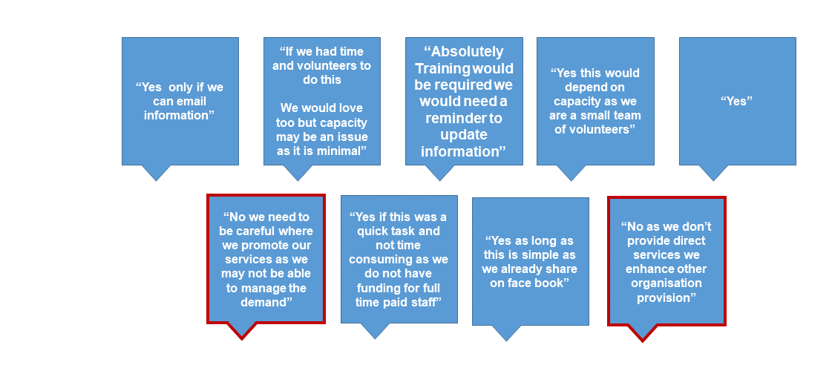

Feedback 27 and 29 (outlined with red border) have advised that they would not be able to input into an aggregator and the reason for this is caution that this would increase footfall which they would struggle to manage for services they offer, as they are referral based and the organisation have limited staff resource:
- “No we need to be careful where we promote our services as we may not be able to manage the demand”
- “No as we don’t provide direct services we enhance other organisation provision”

The feedback above outlines the willingness of organisations to get involved however the majority of organisations have expressed concerns around having the time and resource to commit. Some organisations especially those that are volunteer led would require training and ongoing support to enable them to make this a success. The solution will need to be easy to use, regular reminders will be needed for all organisations to help them build this into work practice.

How organisations would input into an aggregator

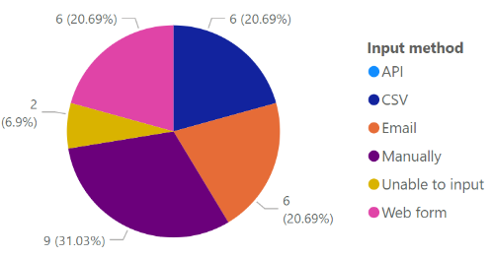

The main scope of this user research was to identify how VCFS organisations would input service information into an aggregator. We identified that organisations had a limited understanding in relation to aggregation. VCFS organisations would need a simple tool which required minimal resource in order to input and update service information.

9 organisations would be willing to manually log into a portal or web based platform that allowed them to log in and update information. However as part of our research 7 organisations have provided feedback that they already input service information on to web based directories however only 2 have continued to ensure that the service information is up to date. 5 organisations have not been able to prioritise keeping the directories up to date due to lack of resource and service priorities.

6 organisations have advised that they would be happy to use a web form to submit information and changes. These organisations are familiar with using different web forms such as google forms, Microsoft forms and Jot forms.

CSV was also a popular choice as 6 organisations would prefer to send information in on an excel spreadsheet.

Email was the chosen method for 6 of the organisations interestingly these organisations were all volunteer led and they felt that this would be the only method that is manageable with the limited resource to be able to input service information.

No VCFS organisations chose API as an input method.
2 organisations have advised that they would not be able to input into an aggregator and the reason for this is caution that this would increase footfall which they would struggle to manage services they offer as they are referral based and the organisation have limited staff resource.

Feedback that we received from organisations was that high-level information about services would be more manageable to keep up to date rather than detailed information on specific sessions or projects.

Establishing what differences there are between the CSVs and whether or not they are broadly standardised to enable easy adherence to the Open Referral standard.

Our research has highlighted that currently organisations have no consistent methods or formats when it comes to storing and sharing information. Data standards in relation to service information has not been a consideration for organisations.

This research project has highlighted this topic with the majority of organisations reflecting that they need to improve practices. Organisations have embraced conversations around data standards and are willing to work with BwD capacity dependent. All organisations have limited or no knowledge of Open Referral UK Standards which means that in any future developments, awareness and training support would need to take priority before any implementation.

Common themes
- Limited resource to consistently keep service information up to date both internally and externally.
- All organisations share service information however the format is not consistent or standardised.
- Overall, organisations have very limited knowledge of Open Referral UK standards (if any).
- Limited experience of inputting service information into online directories.
- No organisations use service directories to find local information, most organisations have staff members or management that have worked in the borough for 20+ years, so naturally utilise organic partnership connections.
- The storage of information is not consistent across organisations. There are also evident digital skill gaps.
- All organisations have expressed a willingness to improve processes that help keep service information up to date.
- If the organisations have an active website then this is usually kept up to date and amended when services change.

Findings
- Keeping service information up to date would not be a priority for an organisation if this meant that it would impact the day to day frontline operations.
- Limited experience of inputting into a system using structured or semi structured data standards.
- Some organisations are unwilling to trust information online in case this is out of date and would only sign post to an organisation direct for more information.
- Organisations have common trust working with the council and would be willing to support the development of improvements in accessible information across BwD.
- Any data requirements requested from organisations would need to be kept to a minimum.
- Training needs would need to be adapted to meet specific and varied skill gaps as not all organisations have the skill set to be able to standardise information and confidently use a digital tool.
- Some organisations found it difficult to participate with the research as pressures and demands on the services have had to take priority.
- Since the pandemic a lot of volunteers supporting the organisations have been unable to continue due to a variety of reasons. This means that employees have had to pick up additional tasks that had previously been a voluntary role.
- The cost of living crisis has meant that some organisations have seen an increase in resident contact meaning that participation in any near future developments would be minimal.

Additional resident research

To ensure that we had a holistic view on the project we engaged with local residents that presented at the council buildings.

The purpose of this study was to determine how people within BwD:

- would search for information if they required support
- do they think it is easy to find the information
- if not … why
Collecting these findings will provide us with the necessary information too:

- Establish those who are not aware of the support available within BwD.
- Make the necessary improvements to allow those who require support and advice.
We spoke with people who visited Blackburn and Darwen Town Hall. Their ages ranged from 18- 90 and included a mixed groups of ethnicities.

Below are the findings from those who took part in the user research:

- 20% would not know how to search or find the information.
- 17% would visit the Blackburn / Darwen Hall.
- 15% online search / Council Website.
- 15% ask family or friends for support.
- 12% would contact Age UK.
- 6% check local paper or social media.
- 3% visit the library, or contact Citizen Advice.

Options and recommendation

Outlined below are options for going forward.

Option​ | Recommendation | Benefits for user | Benefits for business​ | Risk​
1​ | Do nothing​ | - None​ | - None​ | - No up to date information
2​ | Update BwD website and create content with links to external information sources. | - Will be able to view at any time.  - Easy for customer to replace.​  - Trusted information source. | - Less resource intensive.​  - VCFS organisations responsible for own information. | - Accessibility  - No influence over data standards
3​ | Work with Greenwich council to develop a council service directory. | - Single source of information.  - Trusted information source.  - Accessibility standards will be met. | - Using free open source code from Greenwich.  - All service information will be in one location.  - Council will be able to influence data standards.  - Tested and implemented by Greenwich.  - Collaborate with other local authorities.  - Open source community product. | - Organisations will not keep the information up to date  - Organisations will need training support  - Organisations resource  - Resource cost for development and staffing (BwD)  - Will not be utilised
4​ | Develop an aggregator | - Single source of information.  - Trusted information source.  - Accessibility standards will be met. | - All service information will be in one location.  - Council will be able to influence data standards. | - Organisations will not keep the information up to date  - Organisations will need training support  - Organisations resource  - Resource cost for development and staffing (BwD)  - Will not be utilised

Based on the research option 2 & 3 are currently the most feasible options.

Option 1 – Do nothing at this stage would not be supportive of our VCFS organisations

Option 2 - Update BwD website and create content with links to external information sources. This is a quick fix however not a long term solution.

Option 3 - Work with Greenwich council to develop a council service directory. Working in collaboration with another authority will benefit all stakeholders.

Option 4 - Develop an aggregator – BwD would need to source funding for this option.

Next steps

This research will be used to inform other areas within the council including the upcoming development of Family Hubs and Adults social care improvements. This research will be presented to:

- Adults Senior Leadership Team (SLT)
- Family Hubs team would like to use a directory, this will ensure that findings from the User Research are considered as part of design and implementation of wider projects.
- We will continue to follow the Greenwich journey and adopt any learnings from the ongoing project.
- Write a blog on the journey that has taken place that can be shared with other local authorities that may use the findings from the research.
- Share the information on Slack for other local authorities that may be interested in the findings from the research.
The report for senior leadership will also consider how best to energise and martial efforts to enhance the provision of digital service information, and take advantage of opportunities as they arise, including the requirements for a collaborative approach to visioning and project planning.

