Moving House
Discovery Project User research report

Contents:

- Research goals
- What we did and who we spoke to
- Key themes and insights
- User personas and categorised user needs

1.0 Research goals

Discovery research began in January 2019. Our research goals for the user research were as follows:

- Identify how users notified the council of their change of address and learn about their experiences.
- Identify likes and frustrations throughout the process
- Identify what the users needs and expectations are

2.0 What we did and who we spoke to
Participating local authorities recruited users who were contacting the in-scope services to advise they had moved address. When speaking to recruited users to arrange interviews, many of them chose not to participate in the research. Of those who agreed to participate, most preferred the interviews to be conducted over the telephone.
We spoke to 12 users from 3 of the participating local authorities. 2 interviews were conducted face to face, 10 interviews were carried out by telephone.
6 front end staff from Sunderland City Council took part in a focus group interview.
The interviews were semi-structured and facilitated by the user researcher. Representatives of Sunderland City Council observed a number of the sessions. All users answered the same questions expanding on their own experiences. Following the interviews affinity sorting was used to analyse the research findings to uncover themes and insights.

The questions we based our user research sessions around are contained in this document.

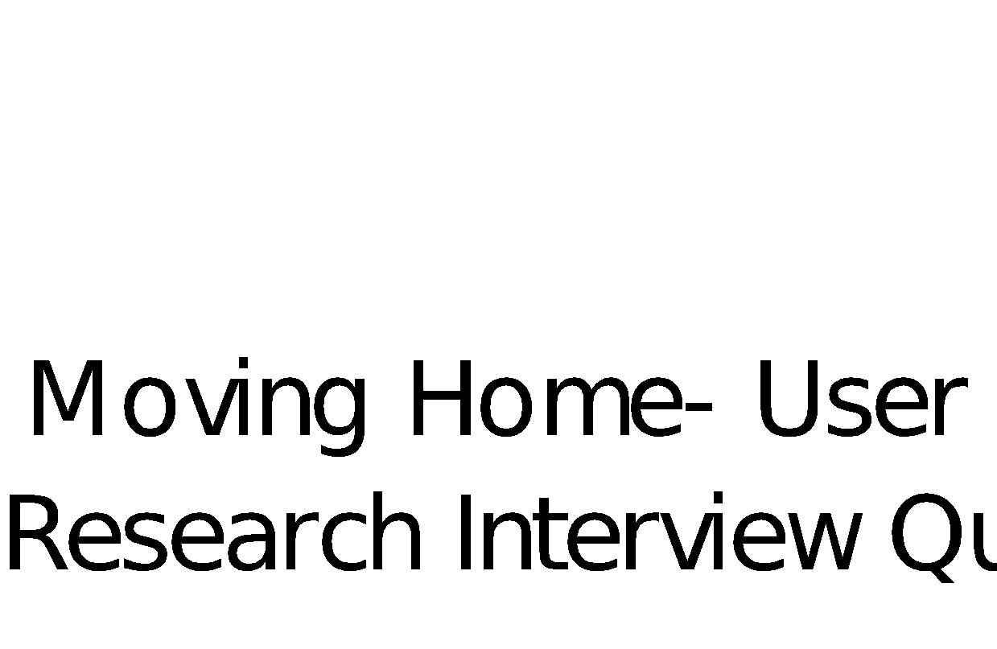

3.0 Key Themes and Insights

The user research found key themes in the experience of reporting a change of address to a council.
A). Users didn’t know they had to inform the council, who they needed to inform or how and when to do this.
Tenants of rented properties expected their landlord to inform the council on their behalf.
‘Customers who are Gentoo tenants thought Gentoo would do everything or they thought we are Gentoo’ Marie – Sunderland Customer Services
‘I went online, I wasn’t getting what I wanted to online to clarify what form I needed to fill in.’ - North East Lincolnshire Resident
When preparing to move home people do not know which services within the council they need to inform, how they can do this and when they need to do it. When phoning one department the information provided is only about one service and not the bigger picture. The process to find the bigger picture is either not complete or involves making multiple contacts.
‘I think when you move home, there should be some sort of list or guide that will tell you the things you need to do, when you need to do them and how you can do them, the timescale you need to do them for the area you moved to’ Kirklees resident
‘Can I get all I need to move home, first time, when I contact the council.’ - Sunderland Resident
When contacting the council to advise a change of address, residents do not know what information they will be asked to provide.
‘I wasn’t sure what information I would need to provide or would be asked when I rang. That really frustrated me’ - Sunderland resident
‘It would be easier if I had notice of what I had to do before the move. I didn’t have any idea.’ Sunderland resident
Occupants of brand new properties are not able to find out the Council tax band for their property.
‘I like to know things before I move’ - Sunderland resident
B). Repetitive, difficult, time consuming process
Council services do not share information. New residents have to contact various services, wasting time, often being held in a queue on the phone or to search online to repeat the same information.
‘Council services are not joined up, I wasted time, repeatedly, notifying every council service that I had moved home for example, the library services, bin services, parking permit. I have to tell them separately that I have moved home’ - Kirklees resident
‘I don’t want to go to different pages on the council website to do a change of address. Electoral process and Council tax separately and differently. I want one page to do them all.’ - North East Lincolnshire Resident
‘One place, one time, one person.’ - Sunderland Resident
‘Our ways of working, in silos, our processes, our teams are not joined up to collaborate so we have prolonged delays before the customer gets the help they need.’ Claire – Sunderland Customer Services
Residents assume that when they inform Council Tax of their change of address other council services will be updated.
‘We get a lot of people who have received an invitation to register to vote form and they have rang up thinking they were already registered as they think they automatically get registered when changing address for council tax.’ Susan – Sunderland Customer Services
The information provided to the different Council services is not done in the same way and in the same place but across multiple channels and multiple processes to multiple people.

‘You just keep repeating yourself. You repeat the same information to different people, different services, different places. It can seem very lengthy’ - Sunderland Resident

C). Residents are not able to provide or receive information when and how they want to

In some local authorities, residents do not have an online option to inform the Council of their change of address. The change has got to be done over the phone, in office hours.

‘Saves me time, I don’t have to call, I don’t have to go to customer service in the council. I do online banking and that is how it evolves.’ - Kirklees Resident

‘I am not a fan of ringing in. I hate being left in a queue of people on the phone for hours, music playing in your ears, and if you have to do multiple calls to different council services, to get to the end result, you can’t possibly lump all of that into the small window of opportunity you have if you work full time 9-5’ Kirklees Resident

‘You want to have that freedom to things when you want because not everyone works 9-5pm’ - Sunderland Resident

When moving address, residents want to be able to inform the council before they move.

New residents expect to receive their Council Tax bill to their new property as soon as they move.

‘I need my Council Tax sorted before I move.’ - Sunderland Resident

D). After informing the council of a change of address, new residents do not know what will happen next.

New residents do not receive their Council Tax bill quickly, the process often takes between 4-8 weeks. Residents are concerned that they will fall into arrears due to the delay.

‘I don’t want to incur arrears on Council Tax, I’m a law abiding citizen.’ - Kirklees Resident

After informing the Council of a change of address, customers are not kept up to date with what is happening, this often leads to them making follow up contact.

‘I moved home and I started chasing them to move my account to my new home.’ - Sunderland Resident

The length of time it takes for us to action the change is wat too long. Lots of people ring back to chase it up.’ - Sunderland Customer Services

Customers are not receiving confirmation information has been received or that records have been updated from some services, this is something that they would expect to receive.

‘Nothing to say what the processing time is. You just wait and hope that the form has been submitted and that you will eventually get a bill.’ - North East Lincolnshire Resident

‘No confirmation from the council side that they had received anything, or that you had done it correctly. You hope all was correctly done.’ - North East Lincolnshire Resident.

4.0 User personas and categorised user needs



