Prototyping an OpenCommunity Data Service model

December 2019

Acknowledgements
This work has been funded by NHS Digital (Social Care Pathfinders Programme) and the Ministry of Housing Communities and Local Government’s Digital Fund.
Thanks to all the organisations in Appendix F who have helped with their inputs to this work, in particular to the Local Government Association whose work with local authorities has informed this study and helps test live implementations of the standard.

Contents
Acknowledgements 1
1. Executive Summary 4
1.1 Background 4
1.2 Aims 4
1.3 Approach 5
1.4 Interoperability for a modular approach 6
1.5 Deliverables 7
1.6 Conclusions 7
1.7 Recommendations 8
2. Background and Goals 8
3. Building on the OpenCommunity Discovery work 10
4. Refining the data model and taxonomy proposed by OpenCommunity Discovery work 11
4.1 Extending and constraining Open Referral 11
4.2 Formal definition of the application profile 12
4.3 Defining the API 13
4.4 Vocabularies referenced 15
4.5 Issues with Open Referral 16
5. Prototyped components 16
5.1 Services directory and API Query tool 17
5.2 Data input 21
5.3 Data entry and assurance via workflow 23
5.4 Data consumption 24

6. Data validation and completeness 30
6.1 Service data validation 30
6.2 Service data richness 31
7. Data assurance and deduplication - The trust model 32
7.1 Uniquely identifying services 33
7.2 Identifying duplicate records 33
7.3 Achieving a trusted record 34
8. Measures of success 35
8.1 Service data quality 35
8.2 Data collection efficiency 36
8.3 Adoption of OpenCommunity 36
9. Next steps 36
9.1 Short term 36
9.2 Medium term 37
9.3 Long term 37
Appendix A - How Alpha work has progressed the findings of the Discovery Report 38
Appendix B - Service data collection and maintenance - cost estimates per service 52
Appendix C - Extensions implemented to the Open Referral data standard 53
Appendix D - Issues with Open Referral 56
Appendix E - Testing feeds between API endpoints 58
Appendix F - Acknowledgements - Who we consulted 59

1. Executive Summary

1.1 Background
OpenCommunity sets out to achieve reliable directories of local services of sufficient quality to be used with confidence to point people to services that will improve their quality of life.
Service data needs to be sufficiently rich, recording locations, costs, schedules and eligibility criteria such that searches can go beyond the capabilities of commercial search engines.
Duplicated effort from maintaining multiple overlapping directories within and between public sector organisation needs to be addressed.
In recognition of these aims, the OpenCommunity project was established by Adur & Worthing Councils, Devon County Council, and Buckinghamshire County Council. It was funded by the Ministry of Housing Communities and Local Government’s Digital Fund. In April 2019 the project published its OpenCommunity Discovery Report - The case for a community-based services data standard.
Joined by Leeds City Council and the London Borough of Croydon the project has progressed to an Alpha stage.
This document summarises the outputs and conclusions of Alpha development work performed in October and November 2019 to build on the prior Discovery work.

1.2 Aims
This Alpha work set out to test an implementation of an OpenCommunity data standard expressed in machine readable terms and used for interchange of data by multiple organisations fulfilling different roles. It is imperative that the service data not only complies with the open data standard but is trusted to be as up to date as possible.
We sought to provide a means of achieving trusted data that can be aggregated from multiple federated directories with duplicates removed. We addressed the mechanisms needed to achieve trusted datasets and measure the success of applying the standard.
The trust model means that consumers, such as the NHS can consume with confidence service data compiled by local authorities and other organisations.
We tested user stories defined in OpenCommunity Alpha work user stories. These are refinements of relevant stories given the “User needs” section of the Discovery report.

1.3 Approach
The Alpha work built on practical experience working with local authorities and software vendors via Local Government Association (LGA) led initiatives. It was performed by four partner organisations:
- iStandUK - the local government standard body - reviewed and prioritised proposed extensions to the Open Referral data standard and recommended an application profile for applying the standard in England
- Porism Limited - expressed the standard in machine readable formats, transformed multiple sample directories into the standard format, developed an illustrative open source directory and provided an Application Programmer Interface (API) for validating, uploading and querying services data
- Placecube - modified its Open Place Directory product to support the standard and provided components to input data to the standard
- DigitalGaps - liaised with local authorities, health trusts and their private sector providers to test the standard and compatibility of software components

1.4 Interoperability for a modular approach
The Local Digital Declaration commits to
“insisting on modular building blocks for the IT we rely on, and open standards to give a common structure to the data we create”
We therefore tested the standard’s suitability for a modular approach whereby different components (directories, aggregators, service finders, ...) can be swapped out without impeding overall operations.
Project partners and flexible suppliers implemented the data standard in interfaces to their components such that individual directories and the systems that consume their data can be swapped out independently.
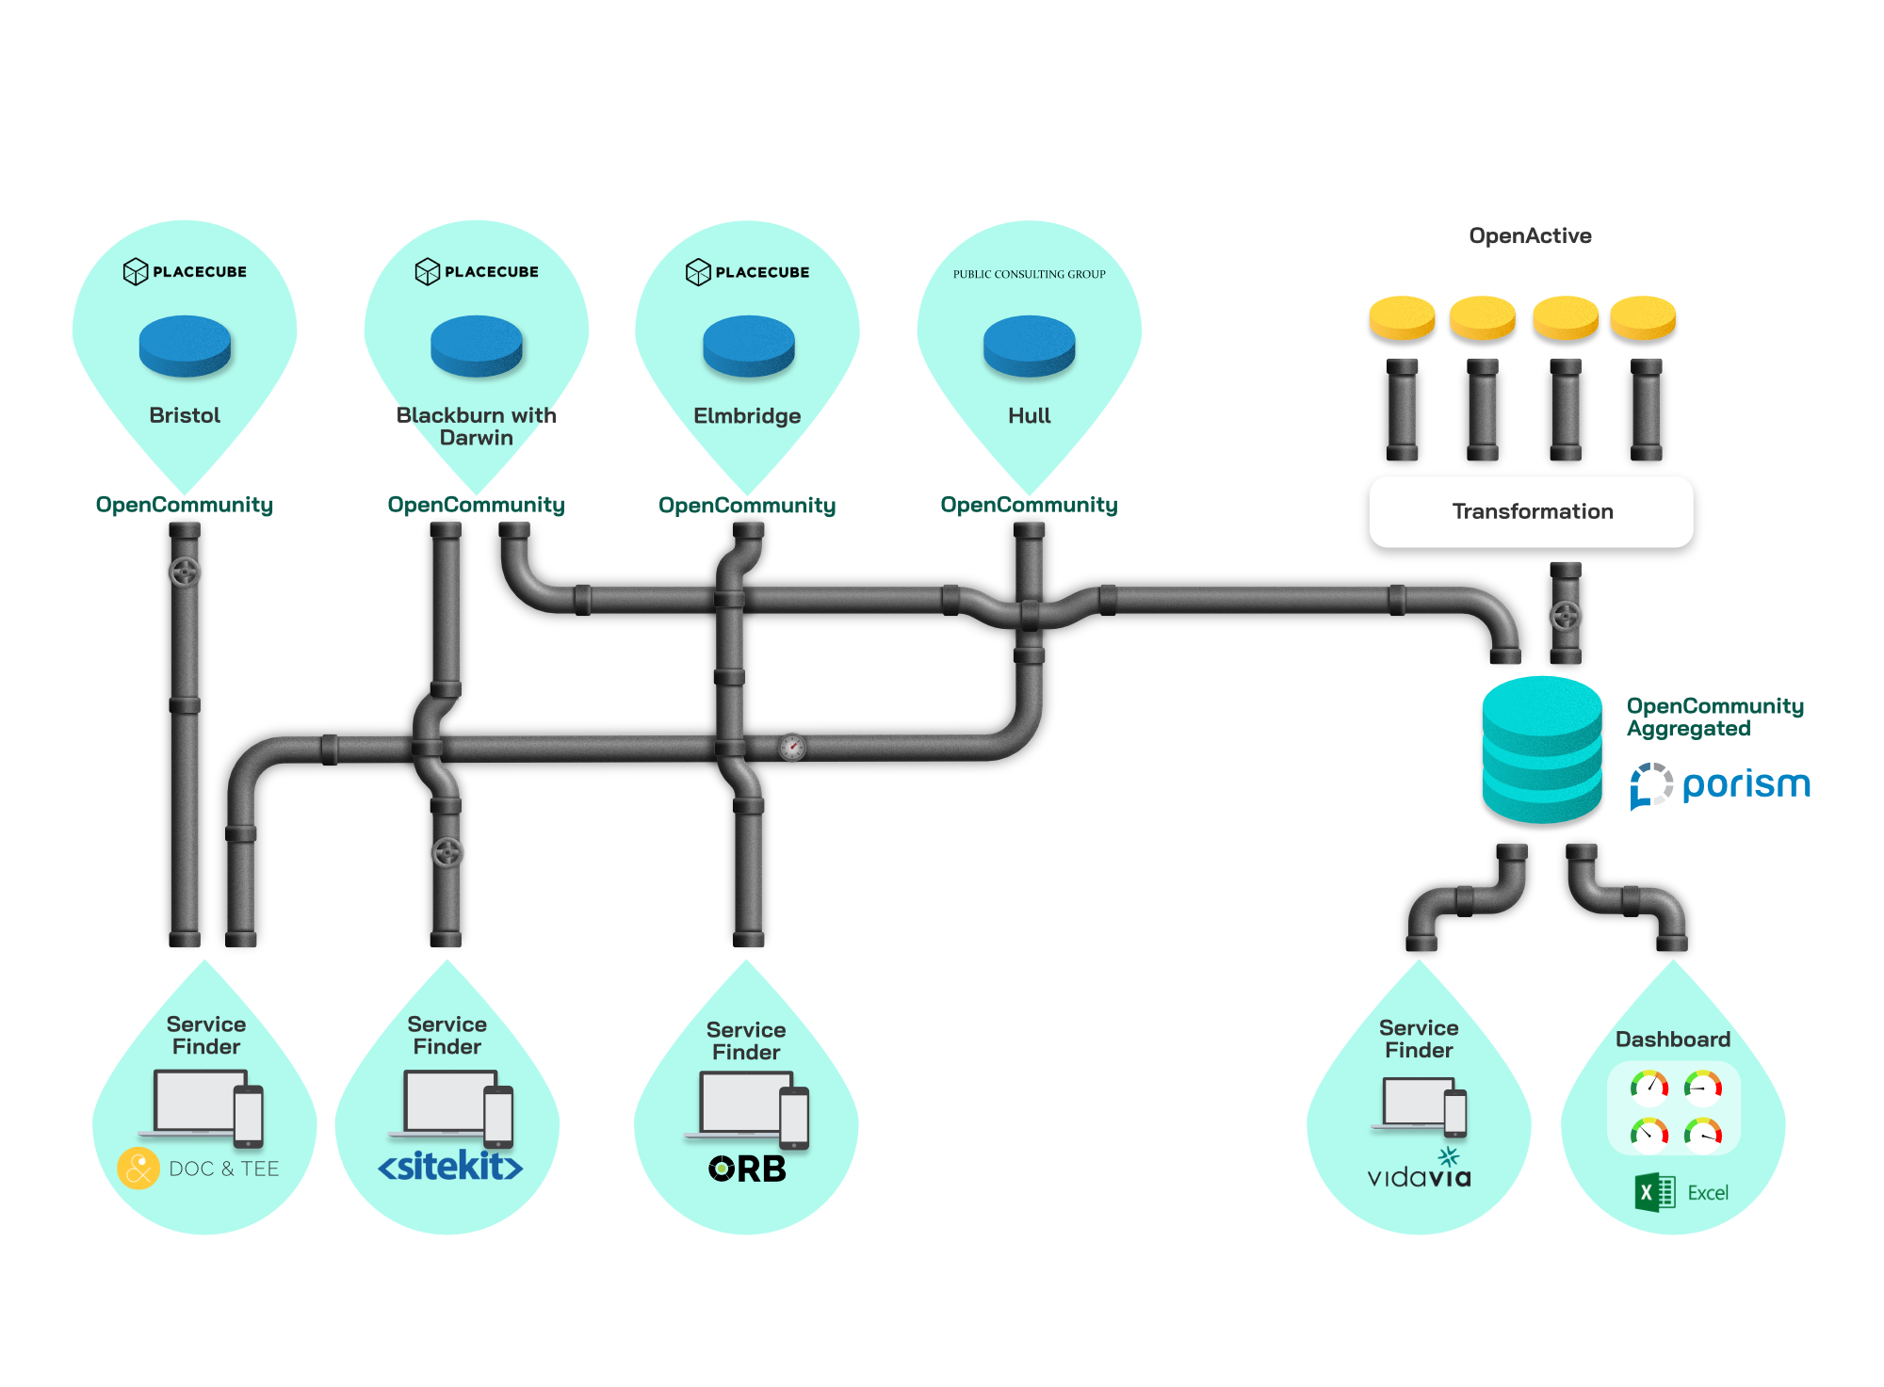
Fixing the plumbing - a module approach to service data publishing and consumption

1.5 Deliverables
We delivered:
- Machine and human readable definitions of the standard with extensions and an application profile suitable for use with local services in England
- Definition of an Application Programmer Interface (API) to query and update service data according to the standard
- An open source service directory implementation applying the standard
- Data converted from Buckinghamshire’s Adult Services directory and test data from multiple other sources converted to be compliant with the standard
- A query tool applying the API to multiple service endpoints belonging to different directories that support the standard
- Examples of open source and proprietary software implementing the standard in directories and “service finder” application, with commitments from other suppliers to do so
- A documented process for achieving trusted directories of services deduplicated and aggregated from federated directories
- Quantifiable measures of data quality and means of measuring the performance of assurers and the reach of OpenCommunity

1.6 Conclusions
- The data standard and trust model (accompanied by agreements between data custodians, aggregators and data consumers) facilitate efficient gathering and sharing of reliable service data for a “place” across sectors
- The modular approach works well although software suppliers need some time and assistance in migrating to it
- Recommendations for extensions to Open Referral have been implemented selectively in accordance with use-cases to support filtering data to a well-focussed list of services and meaningful aggregation and deduplication of data from multiple sources
- Future work must build on Open Referral as extended by OpenCommunity and be strictly compliant with both standards. A governance structure can guide the development of a single standard and discourage it being “adapted” and so breaking interoperability
- We need to go back to the Open Referral community to request the standard be modified to allow wider encoding schemes of allowed values, greater use of external vocabularies and some different JSON representations
- To maintain commitment from commercial suppliers and data consuming organisations, we need a broad governance structure that involves organisations who have committed to it so far and incrementally expands its reach

1.7 Recommendations
We recommend:
- The data standard and means of aggregating trusted data are tested further by work with LGA/DCMS Loneliness project pilot councils
- An “Implementation Handbook” be developed to guide organisations implementing the standard
- Dialogue is continued with the Open Referral community to address issues with the standard and align our extensions with their plans
For OpenCommunity to succeed it needs buy-in from a large number of organisations who fulfil different roles within the service standards ecosystem. We need to define “ownership” across public and private sector organisations.
Sports and Wellbeing data delivered via API feeds compliant with the Sports England OpenActive standard may be seen as a subset of services data. Closer integration between OpenCommunity and OpenActive is recommended.
The data standard needs ongoing technical coordination and continued provision of tools to illustrate its use and test implementation by different suppliers. This is particularly important as it moves towards critical mass. Additional recommendations from the Discovery report should be implemented if and when justified by use-cases.

2. Background and Goals
The work described in this document was performed as an NHS Digital Pathfinder and MHCLG Digital Fund. It builds on prior work by Open Referral, the LGA and the OpenCommunity Discovery phase. As such it is described as an Alpha implementation of Open Referral, testing and refining the findings of prior Discovery work.
Our work overlaps with service standards work being performed by the LGA and the Department for Digital Communities Media and Sport. A place-based pilot of the approach to achieving a quality assured single directory of services is expected to follow in Lancashire and South Cumbria.
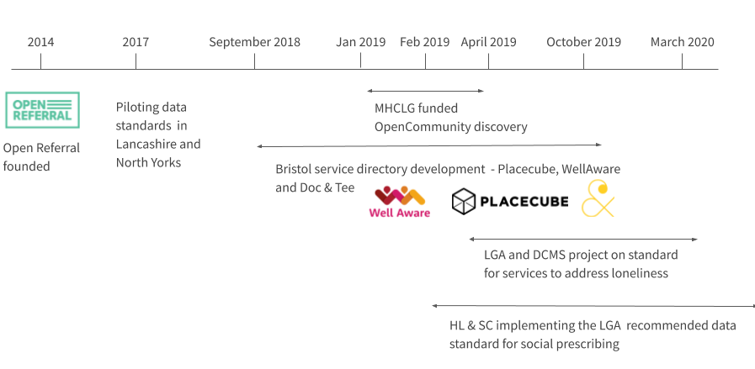
Timeline of OpenCommunity and related work

The specific goals of the work were to provide an early implementation of the standard that is compliant with and extends the Open Referral standard. Extensions were prioritised from Discovery work recommendations and consultation with health trusts, local authorities and software integrators.
We set out to:
- Express the standard in human and machine readable ways to provide unambiguous was of validating and interchanging services data
- Test and illustrate usage of the standard with software integrators such that commissioners and front-line workers can assess its effectiveness
- Describe the different roles in using a place-based services directory and their data and software needs
- Describe means by which service data from multiple sources can be assured, aggregated and de-duplicated

⌨ Further work
From dealing with multiple organisations, we have articulated the need for an ongoing community of users and governance mechanism. Further work is needed to define how that should work.

3. Building on the OpenCommunity Discovery work
The Alpha project has reflected on the Discovery work, as described in the OpenCommunity Discovery Report, and its recommendations for delivering reliable open data. These reflections can be found in Appendix A.
We consulted on and prioritised “proposed changes” to the Open Referral data standard, described how they can be implemented as extensions to Open Referral whilst maintaining conformance with that standard. We implemented extensions required to achieve (or test) the objectives of users representing each role in the OpenCommunity ecosystem.
We reviewed each role in the standards ecosystem and offered more precise definitions of some. We described the mechanisms whereby reliable trusted service data can be maintained by a clearer definition of roles and their responsibilities supported by the extended data standard and hard measures of data quality.
We have expressed the data standard as definitions of data formats and Application Programming Interfaces (APIs) and tested these with a small number of trial implementers. This work has resulted in some refinements and some areas for further work before we get definitive agreement. Some issues have been referred back to the Open Referral community to get wider consensus.
This approach has shown how important it is to have an ongoing well coordinated technical community, implementation guidance and software tools to ensure we keep interoperability between systems.

4. Refining the data model and taxonomy proposed by OpenCommunity Discovery work

4.1 Extending and constraining Open Referral
The Discovery report identified the merits of building on the existing Open Referral international standard for sharing, finding and using information about health, human, and social services. Open Referral has an established open community of implementers and can be expressed in a variety of formats, including a set of related tables and JSON.
This Alpha work therefore took as given the need to be compliant with Open Referral. Compliance means:
- using the data structure and property names dictated by Open Referral
- populating all “required” properties
- restricting values used to those given by Open Referral where it specified enumerated sets of values
Both the Open Community Discovery report and separate earlier work by the LGA on a tabular standard have identified the need to extend the Open Referral standard with additional fields/properties to ensure data can be sufficiently rich to allow meaningful targeted searches for data. In particular, the Open Referral standard often has free-text fields which work well when someone is looking at an entry, but which are not useful when filtering a list against presented criteria (e.g. client location, circumstances, availability). We have therefore described additional properties to be added to an “extended” Open Referral.
The extended standard is then “constrained” by an application profile that recommends how it should be used in the context of English place-based services. The application profile shows which fields in the extended standard we recommend are populated and included in data interfaces. It also specifies any vocabularies from which taxonomy terms can or should be drawn in the context of English services.
Open Referral schema
Open Referral schema
Application profile
for
Extended
extended schema
Extend
Constrain
The document Community Services Data as an Application Profile of Open Referral takes the specific recommendations from OpenCommunity Discovery work, compares them with requirements identified by the LGA version 1 CSV standard and makes MoSCoW (Must, Should, Could, Won’t) recommendations for their implementation.
The Discovery report states “Rather than incorporating everything in a standard, build a first version that allows as many people to adopt it as easily as possible, and iterate based on the needs of the community.” Hence only “must have” and “should have” extensions identified from user consultation were included in the Alpha standard.
Any further extensions should be added by consultation with a community of users, noting that we should strive for backwards compatibility and a standard which is incrementally changed at a decreasing rate as its adoption widens.

4.2 Formal definition of the application profile
Open Referral reference documentation uses the Open Knowledge Foundation’s tabular data package format to define the structure of related data tables and their fields which correspond with the data classes and properties which make up the Open Referral. We edited a copy of it to add recommended extensions and annotate the application profile to which properties belong.
The resultant data package with extensions and application profile is given in the schema generator folder of the human service GitHub repository along with code to auto-generate schemas, HTML documentation and an entity relation diagram.
Key resources generated are:
- HTML documentation for the application profile giving the names and descriptions of the objects and fields, our extensions and application profile details such as allowed values and required/optional taxonomies
- Entity relation diagram (ERD) for the application profile - this is a manually tidied version of the auto-generated diagram
- JSON schemas for key classes:
  - Service - simple verbose
  - Organization - simple verbose
  - Location - simple verbose
Simple schemas define the properties of a class (eg a service) and any other class associated via a many-to-one relationship (eg the organization delivering a service). Verbose schemas additionally include classes associated via a one-to-many relationship (eg service reviews).
In addition to JSON schemas, CSV schemas are provided in the CSV format used by the LGA’s data validator. This format is not useful for complicated data structures as it requires repeating values to be pipe-delimited within cells. However CSV is of value for analysis of extracts of data in spreadsheet and Business Intelligence tools.
Note that the above links reference the extensions and application profile implemented combining high priority recommendations from OpenCommunity and LGA research. Appendix C summarises extensions implemented to the Open Referral data standard.
We also auto-generated an entity relation diagram with MoSCoW priorities to illustrate what a full implementation of OpenCommunity Discover proposed changes would look like.

★ Recommendation
We recommend that such changes be considered for implementation in this way if and when corresponding use-cases arise.

4.3 Defining the API
The JSON schemas specify the format of JSON responses to the main web methods in an API that is compliant with the standard and documented in Swagger. Hence the three schemas referenced in section 2.2 above correspond with responses to the /services, /organizations and /locations web methods.
If an API supports CSV output, responses should conform to the given CSV schemas.

4.3.1 Simple and verbose responses to web methods
By default web methods are implemented to give simple responses where multiple items (eg services, organizations, locations) are returned and detailed responses where a single item is requested.
For example:
- Return all services (first page): https://api.porism.com/ServiceDirectoryService/services/
- Return service whose identifier is 000d18bd-f12b-4152-a2fd-9d29f80c90d9: https://api.porism.com/ServiceDirectoryService/services/000d18bd-f12b-4152-a2fd-9d29f80c90d9
In response to requests from integrators, we propose using an optional “/include” parameter to add extra properties to a web services response. Hence:
https://api.porism.com/ServiceDirectoryService/services?include=service_at_locations
adds service locations to a results set.
The /include parameter can be useful when retrieving selected information in CSV format for offline analysis, using a call such as this:
https://api.porism.com/ServiceDirectoryService/services.csv?include=service_at_locations

★ Recommendation
We recommend that Service Directory software providers implement a core minimum set of web methods for getting services, organizations and locations with a minimum set of parameters. We need to log for reference which implementations support which features. Standard naming should be used across all implementations where a feature is implemented.

4.4 Vocabularies referenced
Optional vocabularies are recommended to populate taxonomy terms for different entities as follows:
- Service type from the LGA’s service types list or from OpenActive’s activity list
- Eligibility from the LGA’s circumstance list and/or from the OpenEligibility list
- Service coverage from ONS’s statistical geography or the LGA’s natural neighbourhoods
The LGA maintains complex relationships between servicers, circumstances and geographies. These provide the potential to answer such questions as:
- what services are suitable for particular types of person?
- how does service provision in an area correspond with the make-up of the population, as defined by metrics associated with circumstances
⌨ Further work
On completion of LGA pilot work in March 2020, there should be a review of the extent to which its circumstance list provides accurate and useful definitions of user groups and the value added by links to taxonomies of service types and of population metrics.

⌨ Further work
Work is also needed to assess the effort and reward from referencing services against service types as given by the LGA’s service types list, the Aunt Bertha Human Services list, the OpenActivity activity list, NHS England’s SNOWMED clinical vocabulary and other domain specific taxonomies.

4.5 Issues with Open Referral
Open Referral provides a base standard with consistent terminology and formatting for all users albeit using North American terminology. Compliance with the mandated parts of Open Referral has been achieved with a few minor exceptions which have been raised as issues with Open Referral.
We have also achieved a high degree of consistency with Open Referral’s API Specification.
Four small issues relating to compliance with the Open Referral data format and two relating to compliance with the API are described in Appendix D.
★ Recommendation
Open Community (particularly its infrastructure providers) need to maintain ongoing dialogue with the wider Open Referral Community to:
- Get anomalies in Open Referral fixed
- Advise English extensions to maintain consistency with ongoing Open Referral changes and have these extensions considered for formal addition to the Open Referral standard
- Comment on and steer proposed changes to Open Referral coming from elsewhere.

5. Prototyped components
We:
- developed software components to illustrate how the standards should be implemented
- converted data from different sources into the standard format and made it available through API endpoints
- provided routines for testing the validity and completeness of data
- helped commercial suppliers develop interfaces compliant with the standard and made improvements according to their feedback
A mix of software components support different roles in full ecosystem, as illustrated below.
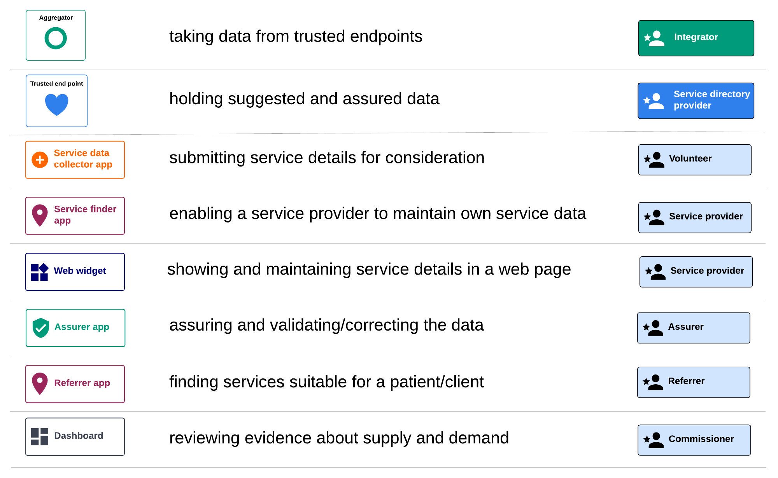
Software tools applicable to different roles

For the Alpha work, we concentrated on service directories taking data from one-another, from suggesters and from assurers, and feeding service data to different “service finder” applications.

5.1 Services directory and API Query tool
We developed an open source services directory which implements the API. Different instances of the directory with different API endpoints were implemented for data converted from Buckinghamshire’s Adult Services Directory, sample data from Bristol, Blackburn with Darwen, Elmbridge, and Hull councils.
A further directory and endpoint was implemented for data imported from a selection of OpenActive endpoints, as given here, describing sports and wellbeing services.
Placecube updated its Open Place Directory product https://www.placecube.com/openplace/ to implement the same API.
The API query tool lets you select any of the above endpoints to retrieve a filtered set of services and view the completeness of any selected service record. The source code for this tool is pure HTML and Javascript which may be copied and run from any location.
We will add further endpoints and enhance the tool as more suppliers support the standard and more directories are converted to its format. It may be necessary to add security to API calls in future if there is excessive demand on endpoints.

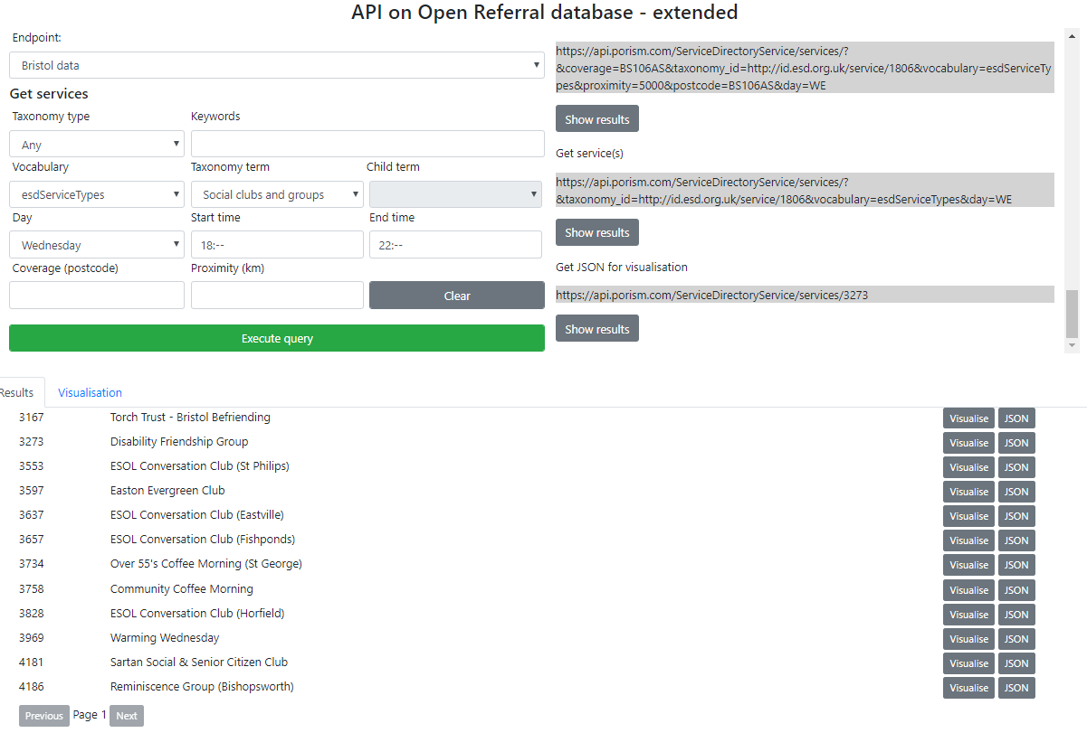
Sample query on an API endpoint

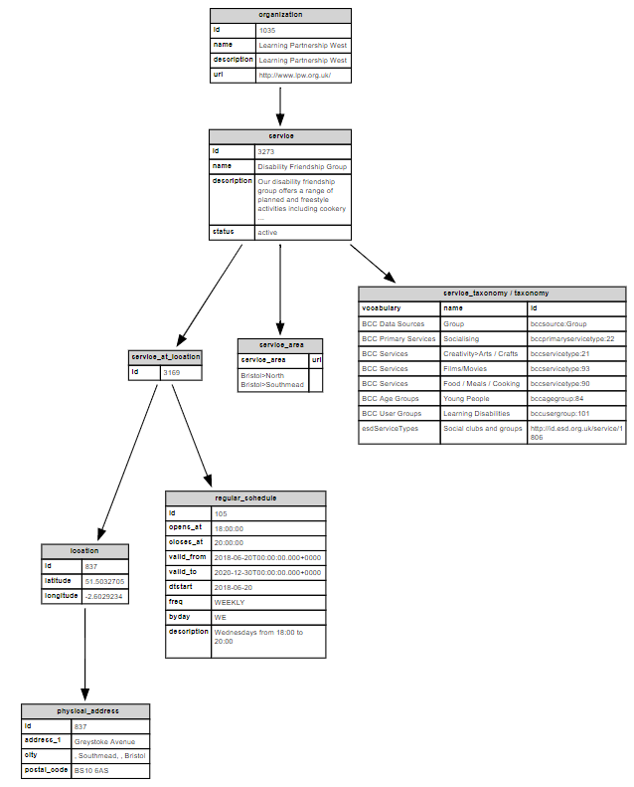
Visualisation of populated properties for a service record

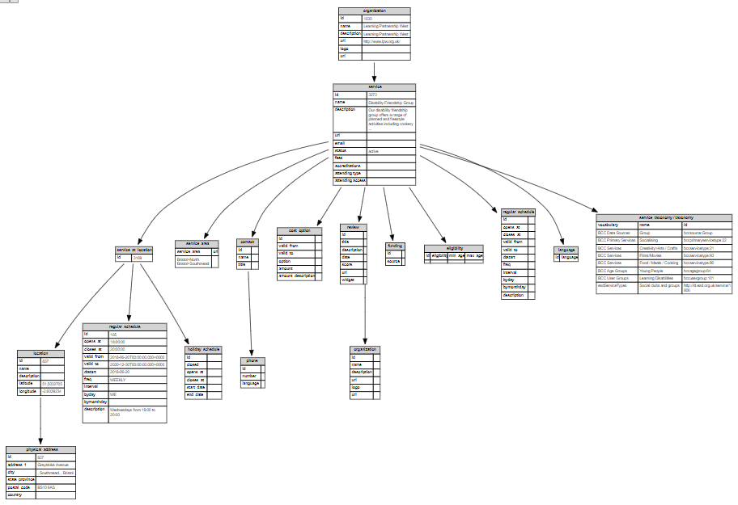
Visualisation of a populated service record including properties not populated

5.1.1 Placecube service directories
Placecube updated its Open Place Directory product to implement the standard API. The company is committed to the Digital Declaration approach of supplying software with interchanging modules that conform to open standards.

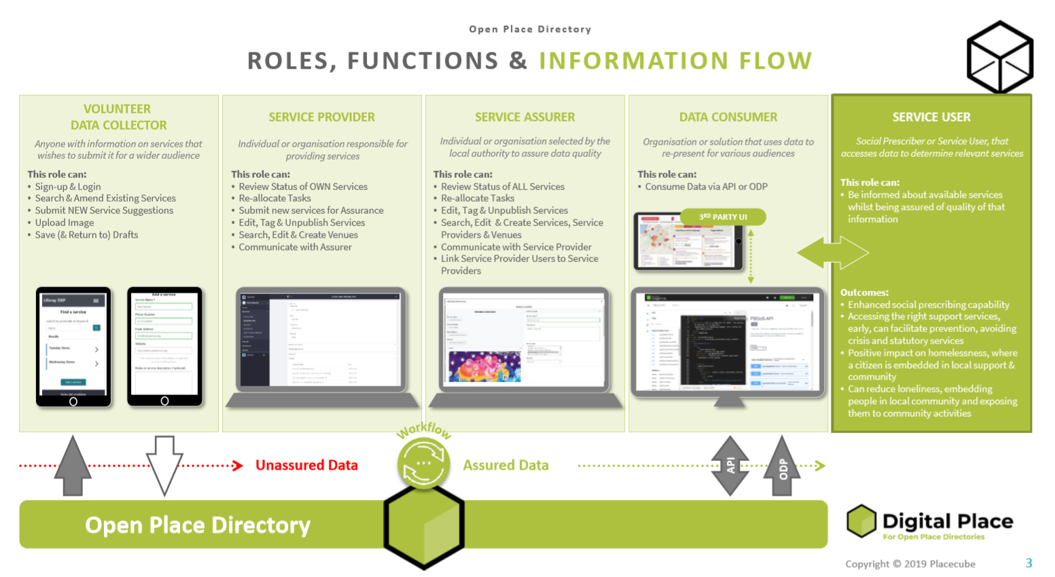

Placecube is working to refine its service directory in parallel with service finder requirements identified by local supplier in Bristol Doc&Tee.

5.1.2 Public Consulting Group (PCG) service directory
PCG has built a custom form for Hull City Council so that local groups can easily upload their data into their Connect to Support website. They have set up a process that automatically transfers this data into their database in the correct format. From this point, they are building an API based on the agreed schema. The API will return a JSON object containing data pulled from their database based on the parameters set in the API. They will then provide documentation on how to consume the API for their requirements.
We expect the API to be live in early December 2019 and will test it as part of ongoing work between the LGA and pilot authorities in its Loneliness project.

5.2 Data input
The open source illustrator directory and Placecube’s implementation both support a POST method for adding new services and a PUT method for updating a service.
The illustration API precedes a POST with an internal validation of the record to be added and rejects it if not valid.
The Placecube POST method posts a suggested service into a workflow process for checking by an assurer before the record forms part of the live directory.
We tested Placecube and Porism APIs by POSTing data from the Placecube API to the Porism API. The methodology used is given in Appendix E.

5.3 Data entry and assurance via workflow
Placecube implements the API via components for adding and assuring records with a workflow such that the publishing organisation can attest to the quality of records exposed
Placecube’s sample Service Suggester illustrates adding a service using the POST method.
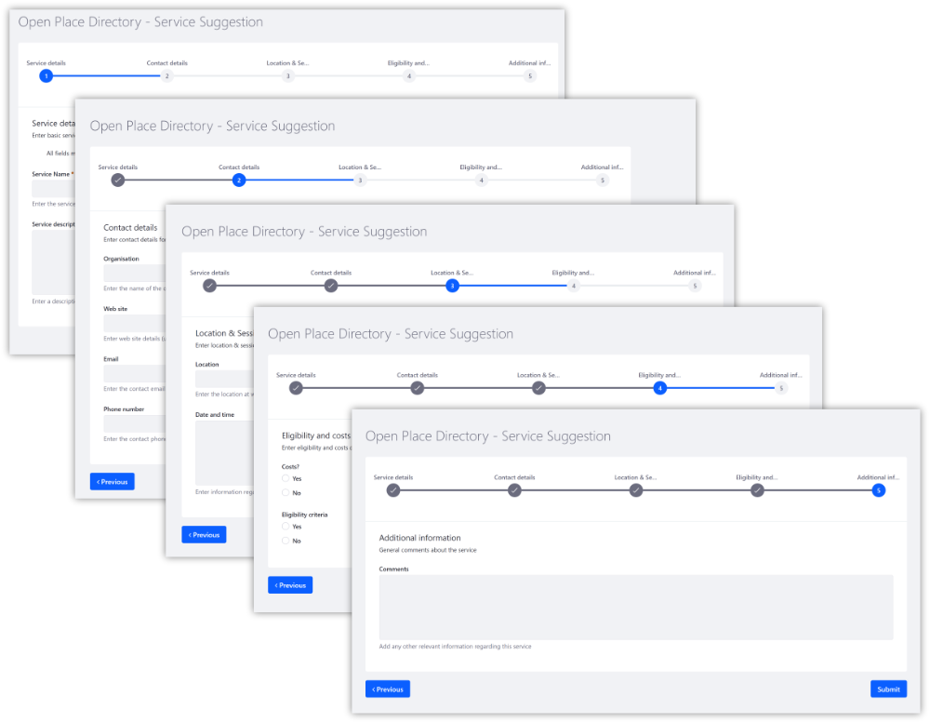
Placecube service suggester module
The Placecube’s “Assure a service” module lets a service be assured before it is exposed in the directory. Assurance may be by an assurer reviewing a volunteer’s suggested service or by a service provider who has been prompted to check that service details remain accurate.
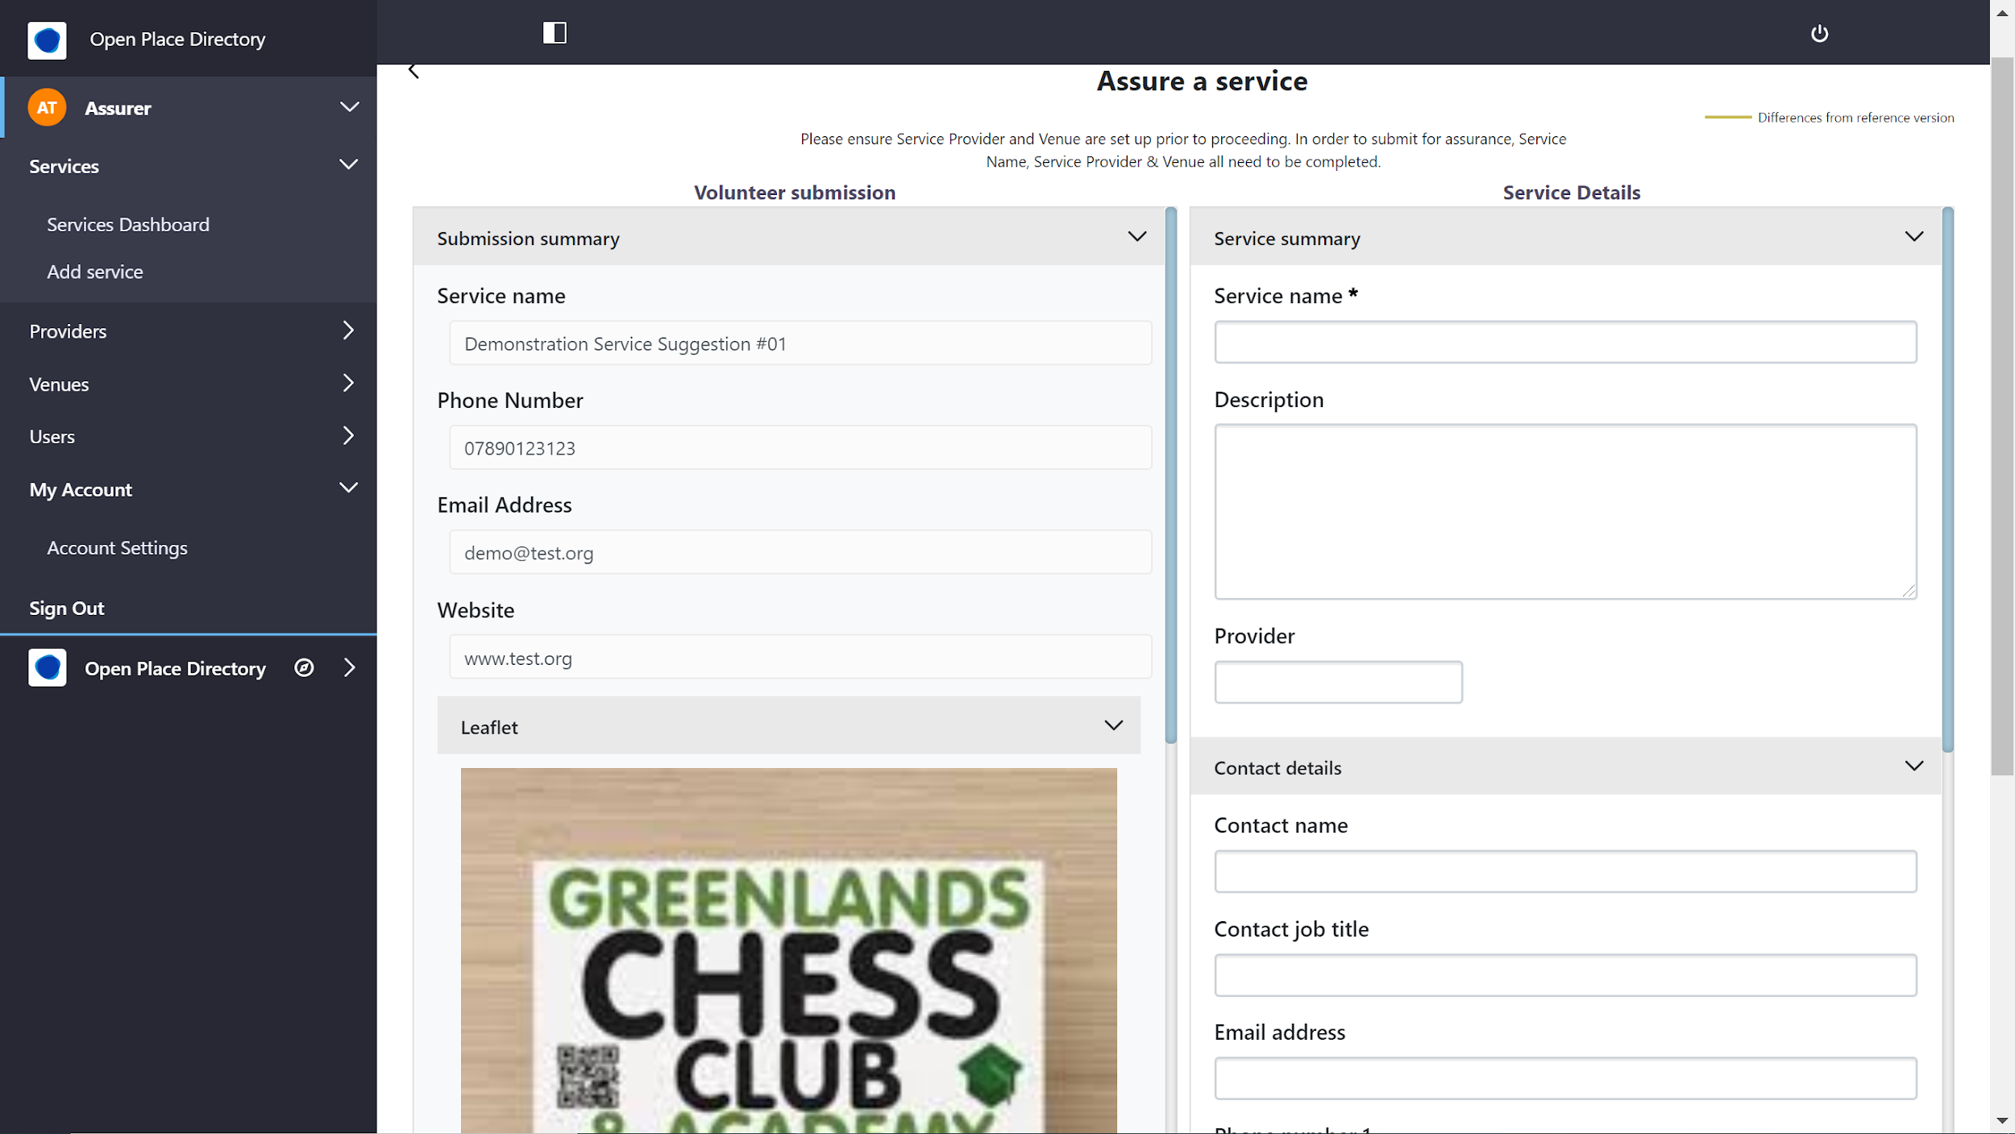
Placecube assurance module for a service
The assurance dashboard shows all services for which a trusted assurer is responsible so that they can initiate assurance where needed.
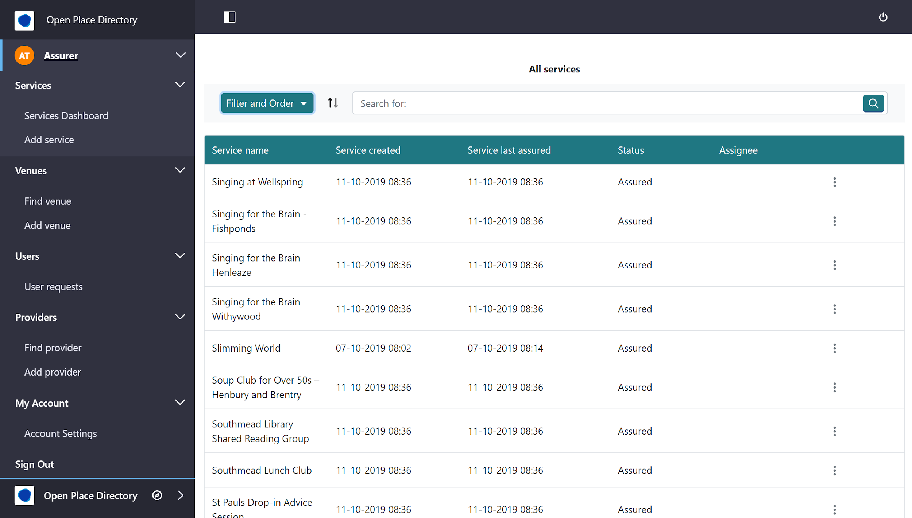Placecube trusted assurer dashboard

5.4 Data consumption
Four commercial suppliers are in the process of developing service finder applications compliant with the API. Hence these applications will be able to work with any directory (or aggregated set of directories) that conform to the standard.

5.4.1 Doc&Tee - Place Based Directory of Services
Doc&Tee is a software supplier to Wellaware who gather, assure and publish information on a wide range of organisations; support groups, community groups, events and activities that can help improve health and wellbeing in Bristol and South Gloucestershire.
Doc&Tee is developing a service finder (user credentials required during the development stage) for connection via the OpenCommunity API to Placecube’s Open Place Directory commissioned by Bristol City Council. Connecting to any standard API endpoint, the service finder retrieves service data for specified eligibility criteria and user interests, as indicated by chosen taxonomy terms.
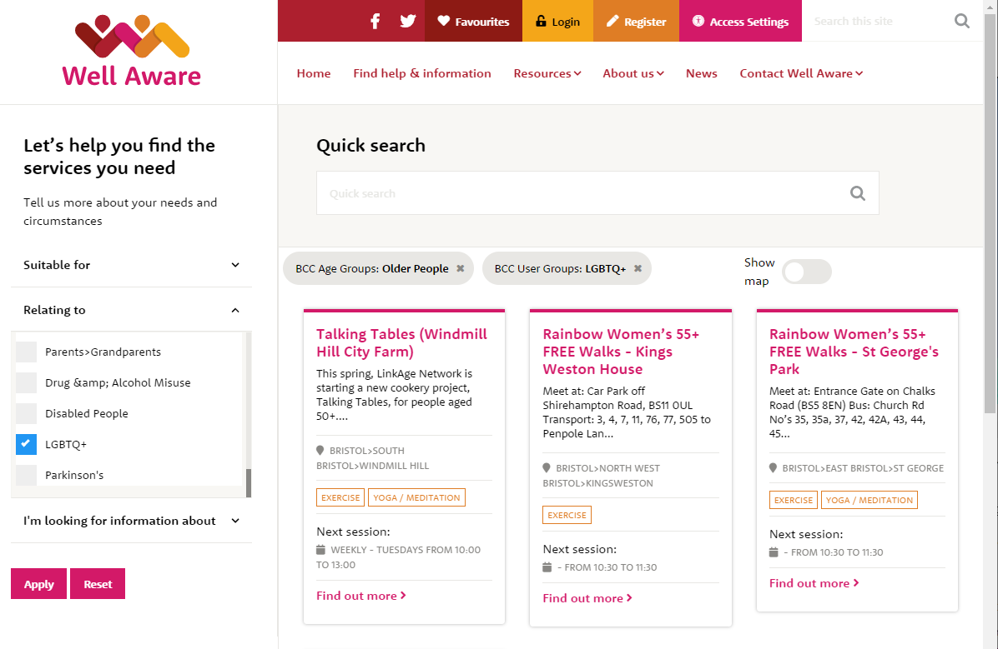
Example Doc&Tee service query for older LGBTQ+ people

5.4.2 OrbUniverse - NHS Orb
ORB is an app that an end user can download from the Apple App Store and Google Play. It provides a digital front door to organise, navigate and access any app or website from a single platform.

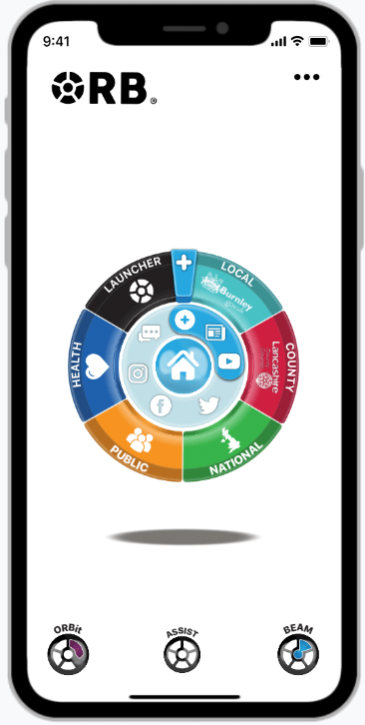
Orb app for smartphones

NHS Orb was sponsored by NHS England and OrbUniverse has been working with the Integrated Care System (ICS) Digital Lead in Lancashire and South Cumbria. NHS Orb can be downloaded freely, used and configured with a user’s own interests on “orbs” that link to other orbs (eg for diabetes), third party applications, websites and a service finder.
OrbUniverse has tested the Alpha Open Community API and confirmed its ability and wish to link to it for finding services relevant to the user based on: information given by the user (eg location and age range), characteristics gleaned from how the user uses orbs and filter criteria input.

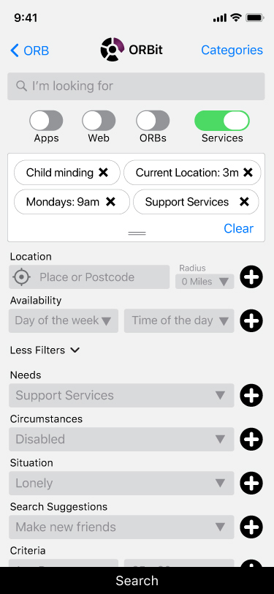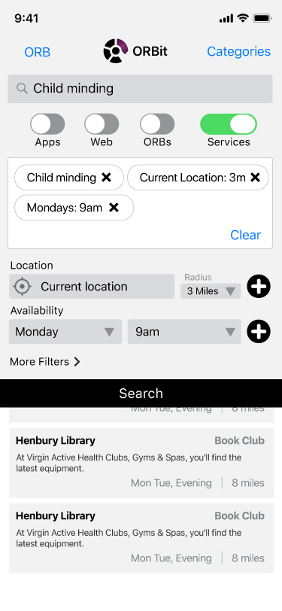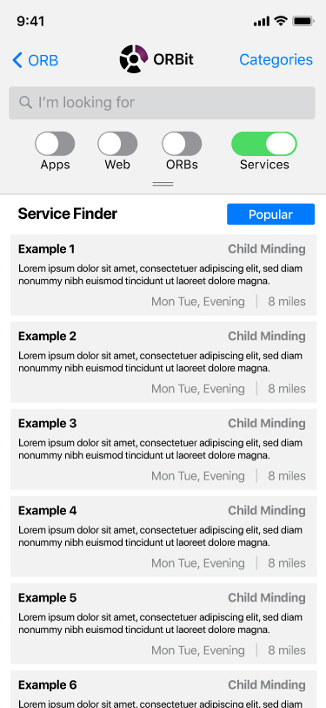
Illustration of Orb finding services via the OpenCommunity API
NHS Orb can also be configured to read in other suppliers’ service finder applications and can be preconfigured to expose these applications.
NHS Orb provides anonymous analytics and behavioural information such that application and data usage can be examined, eg to see the number of searches against a particular criterion and number of results found and examined.

5.4.3 SiteKit eRedbook
SiteKit provides the eRedbook which is a digital version of the Personal Child Health Record, colloquially known as “red book”.
SiteKit is committed to the integration of services data via the standard in order to improve social support for mums/parents/guardians. They have tested API calls to satisfy themselves that they can make the necessary requests to support either self-service by eRedBook users or front line workers via eRedBook professional
Initial mockups by SiteKit are shown below. Precise designs and development will be carried out as part of the Lancashire eRedbook pilot overseen by the NHS’s Digital Child Health (DCH) Programme Manager for Lancashire with an intention to be live by April 2020.

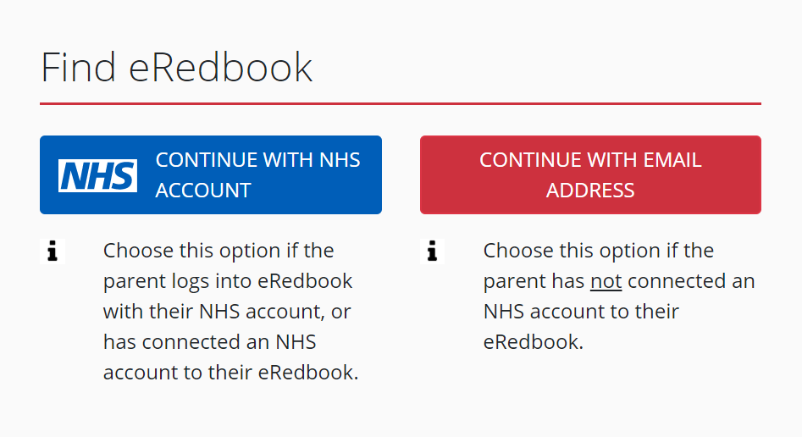 | 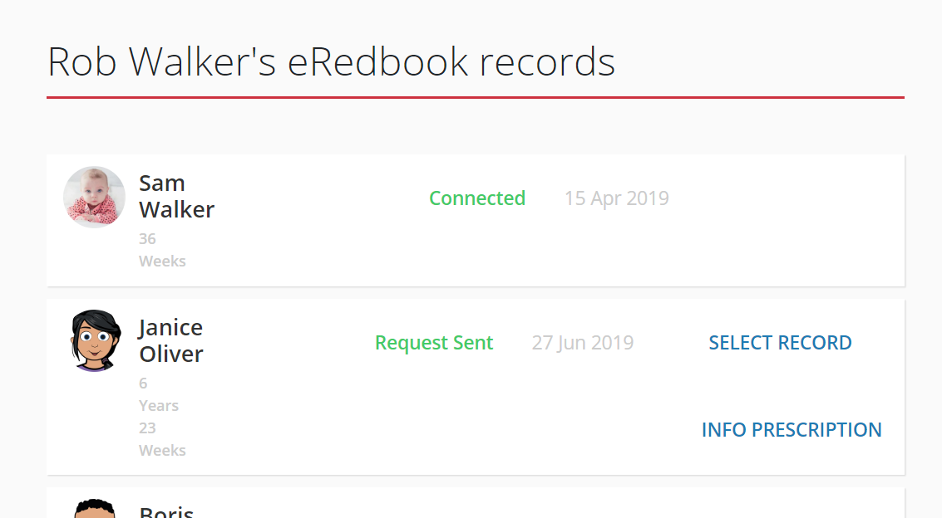

eRedbook Pro client selection
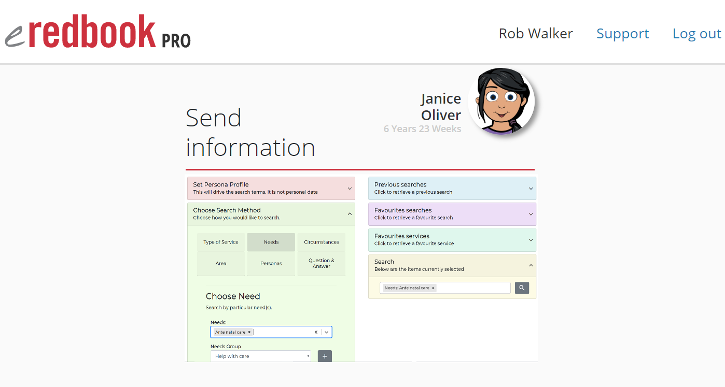
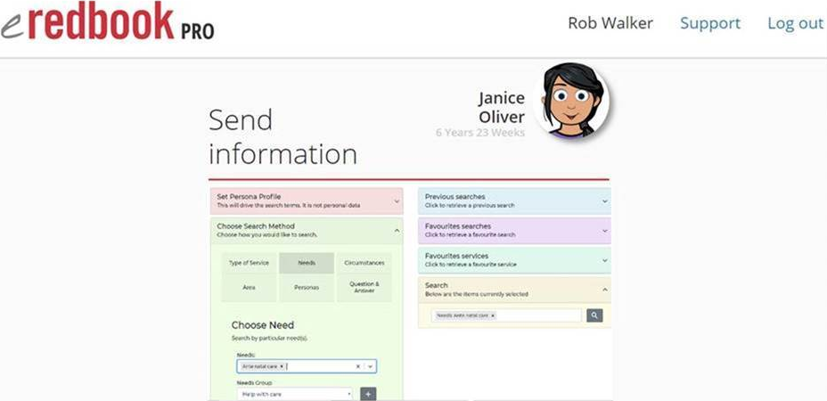
eRedbook finding suitable services

5.4.4 VidaVia Service Finder
Developed as an open source tool to support local authorities piloting the LGA/DCMS Loneliness project, the Vidavia service finder connects to any OpenConnect standard compliant API endpoint to retrieve services according to: service coverage, proximity, age, other eligibility criteria, and suitability to a client’s needs and circumstances.
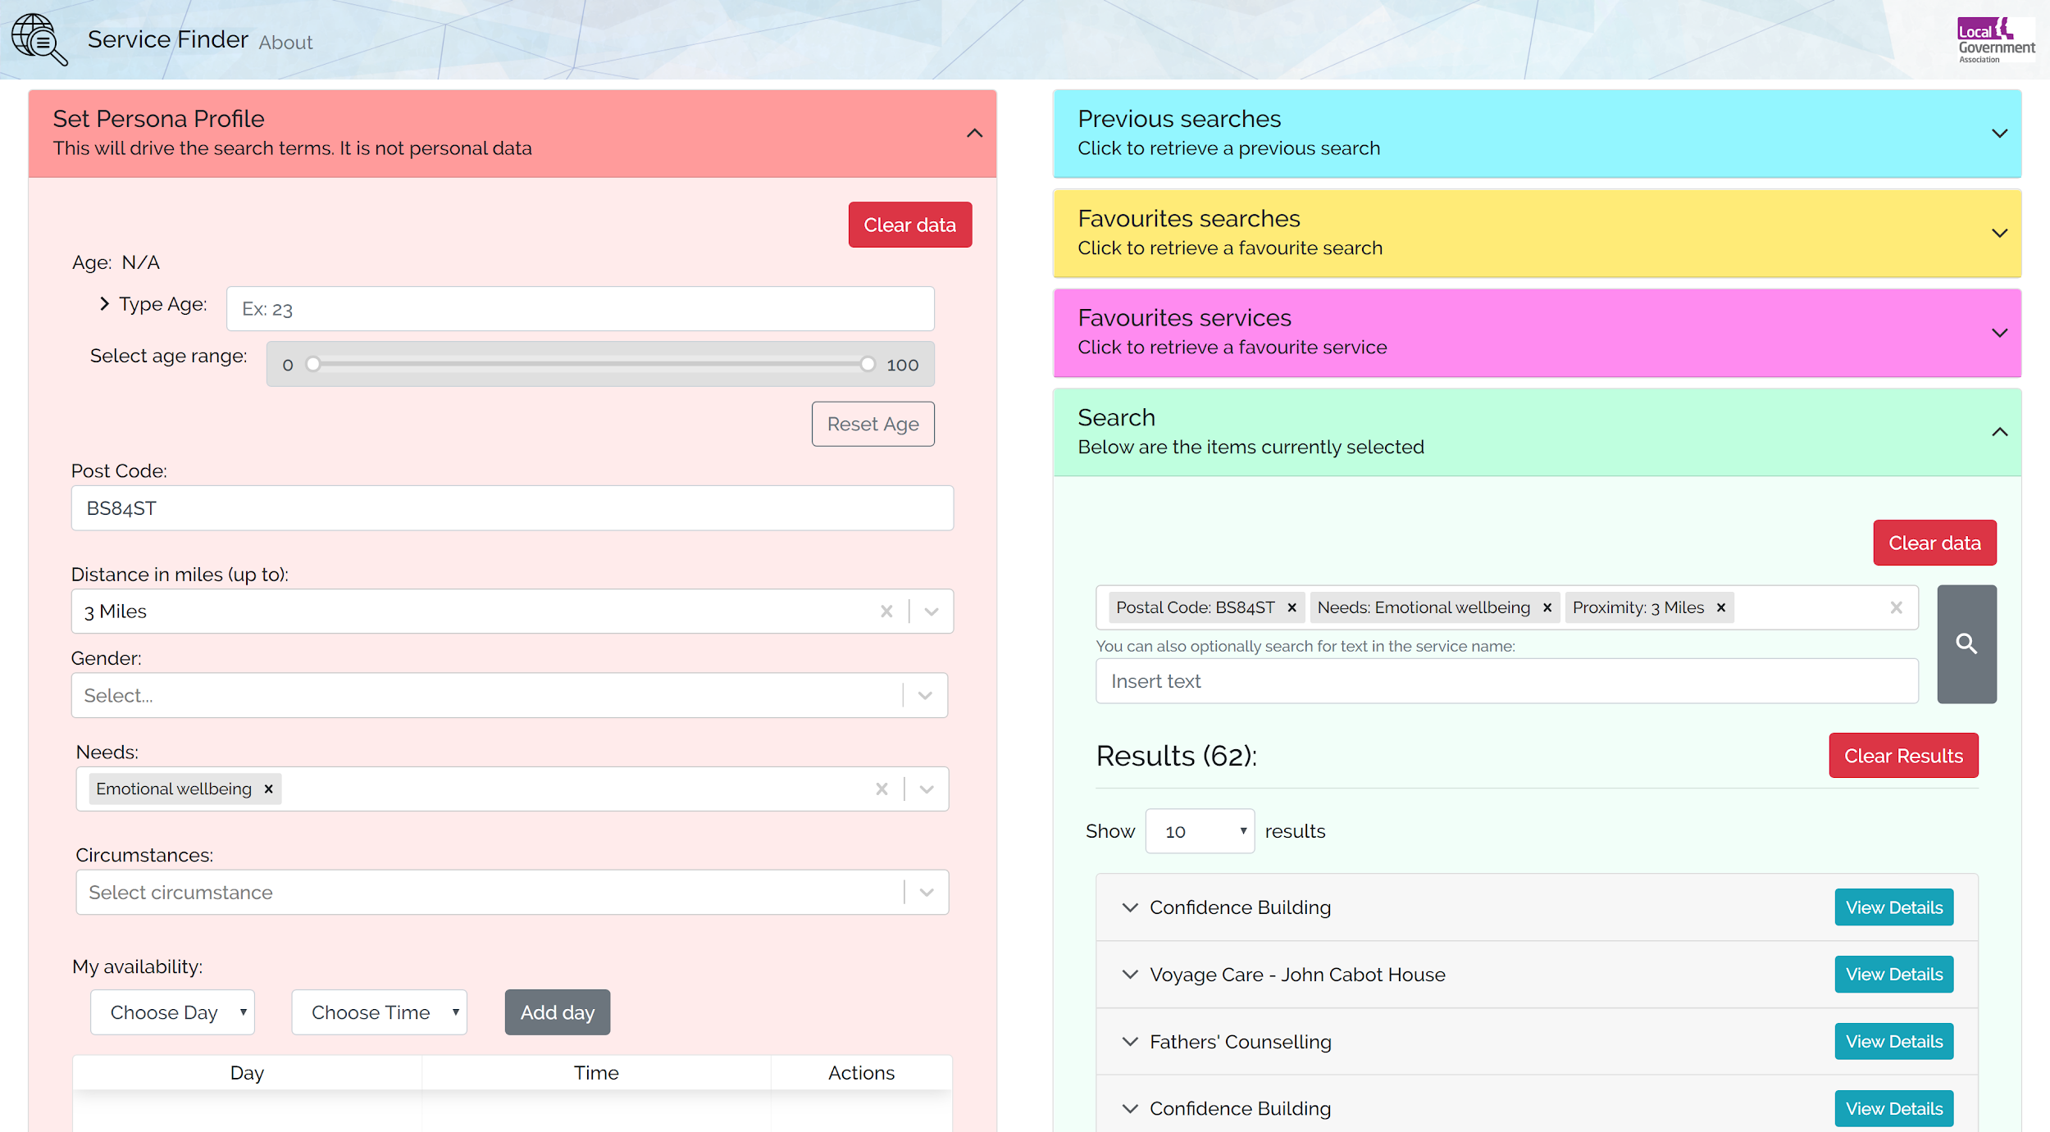
Sample query of the Vidavia service finder
The service finder is designed primarily for frontline workers who can search by different methods. The tool can be configured with “personas” which are named sets of search criteria applicable to certain types of client.
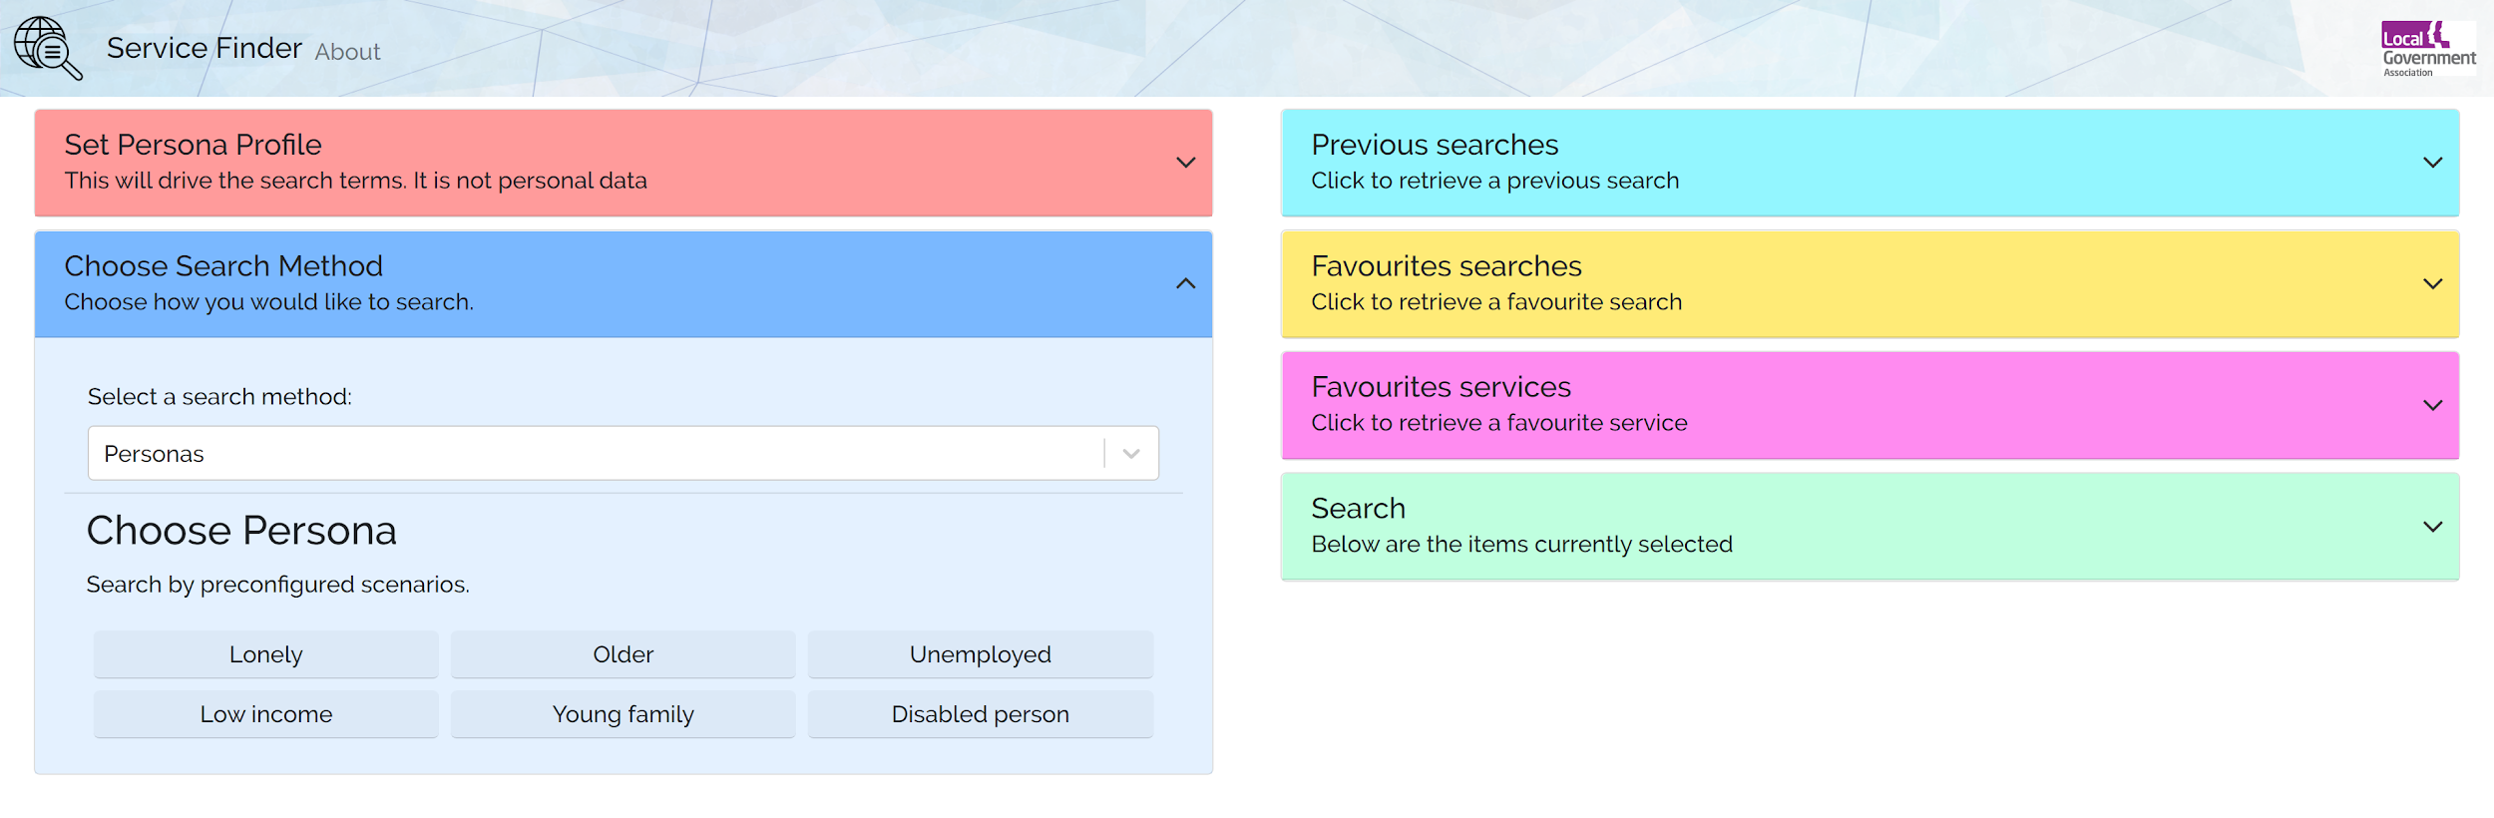
Vidavia service finder - persona selection

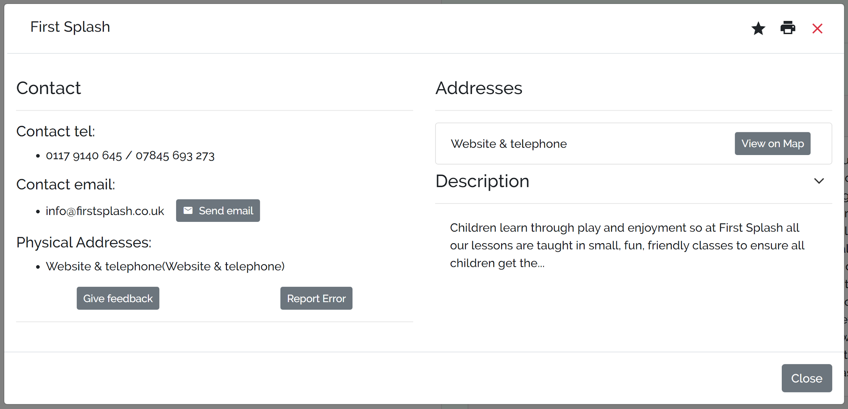
Vidavia service finder - service details popup

6. Data validation and completeness

6.1 Service data validation
We have added to the illustrative API a /validate web method to which service data in JSON format can be posted.
The routine checks that:
- Every required field is populated (not null) if its object is present. E.g. holiday_schedule.closed is required if a holiday_schedule record is included
- Enumerated fields only contain allowed values. The allowed values are case-sensitive
An example of a validation result is as follows (from Elmbridge test data - the Buckinghamshire data is good and generates very few errors).

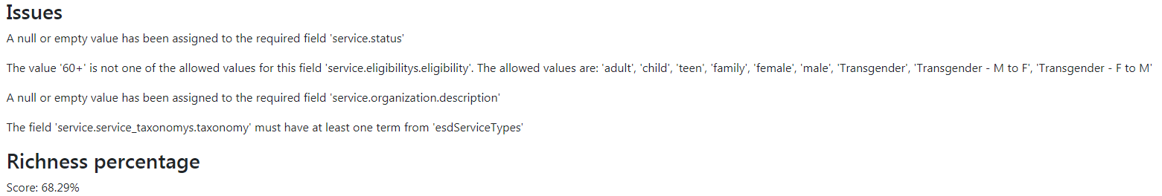

6.2 Service data richness
We have added to the illustrative API richness web methods to indicate the extent to which data fields are populated for a service or set of services
{ ... } Technical note
There are two services:

- A POST service to which to which a single service can be posted in JSON format. This returns a richness score. It can be used to post services from external sources to check the richness of data according to criteria set within the web method being called
- A GET service which can be run on a range of services within the current instance of a service directory to return an aggregate score for records selected. It comes in three ways:
  - A GET service which accepts an id. The existing service in the DB with this id is rated.
  - A GET service which accepts a JSON service. The JSON is rated.
  - A GET service which rates a range of services.

The richness score is the sum of scores applied to specific properties when they are populated or when a date is too far in the past.

We used the component scores given below to run the richness method on data converted or read from external endpoints for the Alpha work. These scores just illustrate how the richness measure can be configured. Actual settings should be agreed according to expectations for each dataset.

service.name = 10
service.description = 5
service.url = 2
service.email = 2
service.attending_type = 2
service.attending_access = 2
service.assured_date = 2 when missing or more than 90 days old
service.service_areas = 5
service.regular_schedule = 2 (only applies when attending_type is “phone”, “online” or “home visit”)
service.eligibility = 2
service.service_at_locations = 9 (only applies when attending_type is venue)
service.contacts = 2
organization.name = 5
organization.description = 2

The overall richness score of a service record or group of service records equals the sum of the scores achieved expressed as a percentage of the total possible score.

Different test dataset scored these approximate richness scores:
- OpenActive data transformed from a selection of OpenActive endpoints - 60%
- Bristol (historic data) - 65%
- Buckinghamshire adult services data - 80%
The main difference in scopes arose from absent service area data. Absent data is legitimate where a service has no official coverage, meaning people from anywhere may use it.
★ Recommendation
Hence different scores for service properties are appropriate for different datasets

.

7. Data assurance and deduplication - The trust model
Much of the success of OpenCommunity rests on its ability to provide a single high quality data record for each service rather than multiple records of varying quality in overlapping service directories. Hence:
- Records must be uniquely identified
- Duplicate records have to be found
- A means of achieving a single trusted record is needed for each service

7.1 Uniquely identifying services
★ Recommendation
Universally Unique Identifiers (UUIDs, known by Microsoft as Globally Unique Identifiers) should be used as identifiers for every service, organization and location.

UUIDs provide a simple way of identifying things as records are moved around. There is no realistic danger of the same identifier being used by more than one publisher.
UUIDs are hard to type manually and can look messy in interfaces, but these considerations are minor because they will be used almost exclusively in machine to machine communication.

7.2 Identifying duplicate records
Rules for record matching services by automated and manual means need to be developed through experience. They will include:
- Matching identifiers using the OpenCommunity recommended extension of identifiers. Identifiers may include:
  - Organization company number
  - Organization charity commission number
  - Organization (or service?) Ofsted number
  - CQC location id
  - Location Unique Property Reference Number (UPRN)
- Matching postcode
- Lat/long within a certain distance from one-another
- Web domain and email domains
- Service|organization|location name and like sounding names
Licensing around UPRNs remains complicated. We recommend UPRNs be excluded from open data until/unless completely open licensing is in place such that they can be used in data published according to the Open Government Licence with no additional caveats. Other identifiers, if correctly applied, can assure exact matches. Matching on other fields will require manual intervention to verify matches from amongst potential matches that computers have found.
Where two or more records match, one must be selected as the main record and others flagged as “replaced by” that record. “Replaced by” records, such as those provided by volunteer service suggesters can still provide a valuable source of information for a trusted assurer to update the main record.
A publisher performing supporting deduplication should publish as open data its “trust log” of records and replacements for other publishers and aggregators to use in removing duplicates from their data.

7.3 Achieving a trusted record
A data custodian (a trusted publisher) will operate a service directory and API endpoint feeding a trusted dataset for a place. The data custodian needs to commit to following quality assurance processes agreed for that place and take responsibility for those processes being adhered to.
The actual assurance of individual records will be achieved by these three roles:
- Data owner - the person/organisation running a service, organization or location who can be trusted for the accuracy of associated data
- Data monitor - the organisation commissioned to monitor and check data and attest to its accuracy
- Data assurer - the organisation commissioned to directly add and maintain records
We propose a new “provenance” field to hold the “owner”, “monitor” or “assurer” role. Where this field has no value, a record should be considered as a suggestion with no assurance of accuracy.

⌨ Further work
The document Deduplication and validation of service data describes the above process in more detail. As live data is received from LGA pilot authorities and others complying with the standard, we will test the process. In doing so we expect to add to the data standard:

- A provenance field for each service, organization and location
- The identifiers table recommended by Discovery work

8. Measures of success
The project has not concerned itself with the efficacy of of social prescribing.
Measures we recommend are limited to the quality of service data, the efficiency with which it is maintained and the adoption of OpenCommunity. The data can also inform commissioners on the use of services and gaps in service provision.

8.1 Service data quality
Hard measures that can be taken from standardised service data are:
- The number of assured records
- The number or proportion of records assured within the last three months (or alternative time period)
- The number or proportion of valid records - see Section 6.1 above
- The richness score of a set of records - see Section 6.2 above
These measures can be used for quality control of service providers who maintain their own records, data assurers and data publishers (and their assured endpoints). They can be built into commitments by organisations and into contracts with paid assurers.

8.2 Data collection efficiency
Appendix B gives estimated costs per service for data collection and maintenance. Actual costs give a good measure of efficiency of data collection when considered alongside data quality measures.
Where improved data reliability results in the removal of duplicate or overlapping service directories, which are common with local authorities, the savings of their removal can be measured.
Likewise, savings can be made and measured where a service directory contains data aggregated from multiple sources, as opposed to local maintenance of all records. For example, many service directories contain records that could be fed from central national sources

8.3 Adoption of OpenCommunity
Simple counts (by role) of organisations adopting the OpenCommunity standard provide a measure of its success. Cost savings are likely to be more than proportional to the numbers of adopters as the potential for sharing data and using common tools increases.
The standard reduces friction in an open competitive market for service directories, service finders and other tools.

9. Next steps

9.1 Short term
As LGA/DCMS Loneliness Projects deliver live compliant data early in 2020, we will evaluate the use and effectiveness of extensions to the data standard - particularly those, such as reviews and cost options that have not been populated with any real data so far.
Placecube and Public Consulting Group are expected to implement their service directories as publishers/data custodians compliant with the standard in a small number of local authorities.
We will continue to provide advice to local authorities and software suppliers wishing to implement the standard.
OpenCommunity recommends development of an “Implementation Handbook” for the standard.
We will liaise with the Open Referral community to resolve outstanding issues that we have logged with them.

9.2 Medium term
In the medium term (say from April 2020) OpenCommunity needs to:
- Establish standard “ownership” across a broad range of public and private sector organisations such that they have confidence to inst in it
- Provide a means to coordinate consultation on technical aspects of the standard in England and with Open Referral. Conclusions need to be built into a maturing standard
- Illustrate effective use of the standard in a “place” with associated trust agreements and software mechanisms in place
- Assess and publicise achievements and failures from work to apply the standard

9.3 Long term
Following initial place-based work, we envisage the standard being applied nationally and adopted by local government, health and other public bodies. We expect use of the standard to be written into procurement contracts.
Hard measures (see Section 8) can be in place and shared publicly to demonstrate the cost, savings and coverage of the standard and richness of the resultant data.
We expect OpenCommunity to be a major influencer in the Open Referral community.

Appendix A - How Alpha work has progressed the findings of the Discovery Report
This Appendix comments on each part of the OpenCommunity Discovery Report to indicate how the Alpha project has built on the Discovery work, where findings are amended and aspects of Discovery findings that were not addressed.
(Page numbers refer to the pagination within the OpenCommunity Discovery Report.)

Summary and Introduction (page 4-6)
The Report sums up the problem as follows:
“Every local authority, health organisation, police force and voluntary sector organisation maintain some form of directory of locally available services, with massive duplication of effort.”
It further explains the challenging problem of local service directories as:
“Every local authority, health organisation, police force, together with other voluntary sector service providers maintains some form of local directory-based information, with massive duplication of effort.
Typically there is little join-up, no data standards, inconsistent quality assurance and little in the way of shared service data. Many directories have artificial geographical boundaries, resulting in patchy provision of information to citizens living near administrative boundaries.”
This Alpha project wholeheartedly supports these summations and builds on the Discovery work to explore how standards can support capturing/maintaining, quality assuring and making available service data.
This project also incorporates lessons from the LGA pilot programme exploring how service information can be gathered and shared to address loneliness. That programme concurs with the above but goes slightly further in focussing on more personalisation i.e. knowing that providing a long list of potential services or signposting to an organisation level or to website home pages does not work well. The LGA programme focuses on providing local support services that are appropriate to an individual’s needs and circumstances and so includes eligibility/entitlement, specific session time to meet availability. It also tests the viability of a model that maps service types to needs and circumstances.
The Discovery projects sets out the these aims for follow on projects:
- Reduce duplication of effort and data.
- Improve the quality and consistency of data.
- Make community services data reusable between existing systems.
- Test and evidence the benefits of data sharing through delivery
This Alpha project has made some inroads into each aim within its two month timescale. It provides a step forward that OpenCommunity can build on as the standard and associated community of users progress together.

What are community services? (page 6)
The Alpha project has widened the scope to include considering any local authority service, rather than being limited to local community services.

What are data standards? (page 7 & 8)
The Alpha project embraces the open data standards recommended in the Discovery and progresses harmonisation between existing standards. It specifies extensions to existing standards to offer a greater personalisation and a wider remit for services. It also defines an application profile which constrains how the standard should be used by OpenCommunity participants.

Who is involved in community services? (page 8)
The Alpha project has explored the roles identified in the Discovery work and mapped them into an end-to-end model of capturing, classifying, assuring and using local services open data. The roles have then been aligned to a standards ecosystem model. A table below under “The community services standards ecosystem” shows the nine roles identified in Discovery and the ecosystem and reflections from the Alpha prototyping.

Key user findings (page 14-25)

Directory users have a wide spectrum of needs (page 14)
Each of the user roles defined by the Discovery project has been reviewed and aligned into the Alpha models. We recognise that directory users have a wide spectrum of needs and that the Discovery report only touches on a few examples.
The variety and complexity of frontend user requirements could inhibit progress on preparing open data. Hence this Alpha work focussed on the following three goals in defining a concrete standard that provides some flexibility to meet a variety of frontend user needs.
- Consolidate the frontline workers into a generic frontline worker
We defined a generic frontline worker to capture sufficient data such that a frontline application can consume it and apply it to a particular context. E.g. a social prescribing application can focus on the user needs of a link worker; a directory of services can focus on the needs of a community connector; an app to support carers can focus on the needs of a carer etc. Various application developers fed back their requirements which we attempted to address in a sufficiently generic way to suit other contexts.
- Use service type as a link from service to service user need
We used “service-type” as a link to any classification model such that various user needs could be mapped to service types in order to surface appropriate services without the service user needing to know what services to search for. The standard is sufficiently flexible to accommodate service types from any recognised local, regional or national vocabulary although common vocabularies needed to be used for all services across a “place” for this approach to be useful.
- Provide aggregation services (including deduplication) and an easy to use APIs
We defined an API and implemented it in an illustrative open source directory. We provided multiple API endpoints for local service directories imported and made consistent with the data standard. We provided an API query tool that can connect to any of our endpoints and to other endpoints that conform to the standard. We defined a trust model for assuring service records and for aggregrating services from multiple trusted endpoints to achieve a single deduplicated set of data for a place built from federated directories.

There are three tiers of referral relationship (page 16)
Whilst accepting these tiers of referral, the Alpha project moves these concerns to be part of the frontend application’s responsibility. This should mean that there will be applications that: focus on the needs of a professional who wants fast access to contact details; someone’s need to create their own favourites; or the ability to set up personas of someone’s client target groups etc.
A standards development community should be able to react when a frontend application requires further data elements in order to deliver their applications. Such extensions to the standard should be demand-led.

Some community services are easier to capture than others (page 18)
This is the most critical issue for the model to address. There is little point in having an open data standard if the majority of service information is not captured. The desk based research carried out estimates that one third of the local support services are ‘hard to capture’ i.e. the service provider is not capable, for whatever reason, of maintaining their own data. In a major city that might be 1700 out of 5000 local services.
Software provides the means to empower the crowd (stakeholders involved in support services: service users, volunteers, frontline workers, service providers and dedicated service maintenance teams) to capture and maintain open data compliant with the standard. Examples of this approach can be found in the LGA’s loneliness local services open data pilot programme.
We have considered a model in which the “data custodian” guarantees the quality of a directory. Within that, responsibility is delegated to four roles: suggester, provider, reviewer and assurer. Applying the model means that the provenance of the data is recorded. In the model:
- a suggester makes suggestions for data changes as part of a volunteering role expecting no recompense
- a provider of a service is incentivised to keep their own data up to date
- a reviewer is required when a publisher wants to check that the service provider is maintaining their data but would expect to pay the reviewer and then
- an assurer is someone who collects and maintains the data on behalf of a service provider
Reviewers and assurers would expect to be paid for their work and a business case has to be made for paying them, whilst every attempt should be made to make use of suggesters and providers. The business case should balance the benefits obtained from reliable data with the costs of collecting and maintaining it.

Public vs professional directories (page 19)
The differences between public and professional directories is considered part of the frontend applications design but the open data standard must ensure it provides the data required to deliver both types of directory.
The following are reflections on the points raised about professional and public directories.

Professional:
- Sensitive data - Our work has been concerned purely with a standard for open data interchange. Hence we have excluded data that might be considered sensitive. Within some directories sensitive data might be held for operational reasons. Such data should be excluded from exports (including API feeds) of open data. Note that sensitive data extends beyond personal data; for example the location of a centre for victims of domestic abuse is sensitive.
- Capacity - There is a risk of latent demand (i.e. demand that cannot be satisfied) so the standard includes an ‘Attending access’ property to allow applications to indicate whether a service user has to apply, book, just drop in or must have a referral.
- Contact details - The standard allows for any number of contacts associated with a service. Data on specific staff working times would normally not be public and so is excluded.
- Fast access to information - This would be a design decision of a frontend application

Public:
- Primary public users - Providing reliable open data will mean that many frontend applications can offer a wide variety of useful (and sometimes specialist) applications which should increase the reach of the data.
- Usability - Separation of data from frontend applications means that specialist and innovative developers can create more usable and appealing frontend applications.
- Visibility - The more frontend applications making use of the open data then the more service users will be reached rather than expecting the service users to make use of one particular service directory for services from one publisher.
- Incomplete data /siloed data - Consolidating the effort of collecting and maintaining data will minimise the risk of it being incomplete or in another directory. We have developed routines to illustrate how the validity, up-to-dateness and richness of data can be measured to help drive improvements in data quality.
- Use of Google instead - Google offers an easy way to search and get some results but further research is still required. If data fed by service directories is sufficiently rich, service finder applications can identify more precisely services relevant to a user based on factors such as eligibility, cost, proximity and suitability for the user’s needs. Hence the standard (in particular extensions to open Referral from openCommunity) supports rich data for each service. There is likely to be a gradual transition from basic valid data to data which offers sufficient richness to for service finder applications to give better results than Google searches.

Siloed directories leads to siloed commissioning (page 21)
In recognition of this danger, the standard, as implemented by this Alpha project gives the coverage and physical locations of each service to enable frontend applications to extract data to fit the geography they are considering from multiple directories via their API endpoints. The proposed model includes aggregation to a council, CCG or Integrated Care System (ICS) level and then nationally. This approach addresses user stories in the Discovery project but any aggregation is possible.

‘I need to be able to trust the data’ means different things to different people (page 23)
The Alpha project separates data quality from service quality. The focus for the data custodian and aggregator services is data quality to provide reliable local service information. Service quality is indicated through service review data. The responsibility and accountability for service quality lies solely with the frontend application as they have the ability to filter to only include services within their quality tolerance e.g. an NHS app may only choose the services with a respected CQC score; a council childcare directory may only show those with an Ofsted rating etc.

Artificial geographic boundaries inhibit people’s ability to access services (page 24)
The Alpha project took on this Discovery challenge by prototyping geographical aggregation meaning that a service user can find services within a specified proximity to their address. Eligibility constraints can be applied via the API to remove services which they are not entitled to based services’ geographical coverage.

Human relationships save lives. Not services (page 25)
The Alpha project has effectively focussed on collecting useful data and ensuring it is reliable rather than dictating how this data is used. The data should empower citizens, family, friends, carers, befrienders and frontline workers. Thinking on how the data is used is decoupled from the open data itself and left to designers of frontend applications.

Designing a standards ecosystem (page 26)

Key recommendations (page 26)
The following are reflections on the key recommendations from the Discovery work

1. Identify clear owners and sponsors of the community services standard
Significant work remains to be done in identifying ownership and governance of the standard.
The Alpha work illustrates:
- Building on Open Referral which has its own online community
- Aligning standards work in England by Open Community and the LGA in association with DCMS
- Interchange of standard compliant data between three service directories and four service finder applications from commercial suppliers
- Transformation of data from the Sports England OpenActive format into the Open Community standard
- Consultation with stakeholders in local government, NHS and the third sector e.g. CA and CVS.
All of these parties have a stake in seeing the standard well maintained and supported in a way that gives them confidence to invest in it. Hence a governance mechanism involving public and private bodies is needed that is not vulnerable to changes of priorities by any single party. An independent body might provide guidance on setting up governance of the standard. We recommend significant further work in this area and investigation as to the extent to which the ODIs’ Data Trusts model might be relevant.

2. Good standards already exist. Work with the standards community to drive their implementation, development and adoption
The Alpha project has built on the existing Open Referral standards, extended it from learning by Open Community and the LGA and expressed it in machine readable formats that incorporate established standards from schema.org and iCal (for schedules). The application profile for use of the standard in England references established controlled vocabularies which are maintained outside of OpenCommunity.
By submitting issues and proposed extensions to communities of Open Referral and OpenCommunity users, we should be exposed to pre-existing relevant standards to build on.

3. Collaboratively procure data systems across teams and organisations who depend on community services data and include standards as a requirement.
The Alpha project has emphasised to participating organisations that a modular approach is required to systems design such that components from different suppliers can be swapped in and out without wholesale switching to a new supplier for all directory services.
There is likely to be some resistance to this modular approach because of commercial interests of a lack of understanding of the implications of the Local Government Digital Declaration.
We propose that a community of organisations signing up to the OpenCommunity approach requires members to:
- Build use of the standard into the systems design, procurement and development processes
- Share the fruits of work done to comply with the standard so as to avoid duplication of effort and double charging

4. Test standards and demonstrate their value through real world use cases with real data.
The Alpha project has illustrated an end-to-end process of collecting, assuring and consuming service data. Most data feeds provided to date are samples from data that is undergoing assurance or data converted from other directories which don’t support all features.
Demonstration of the standard’s value and iterative improvement of the data format and API protocols will come from gradual rollout within a community with feedback mechanisms. LGA work on services supporting loneliness will load and test live data early in 2020. Suppliers who have implemented the standard are improving and testing their software based on needs fed back by public sector clients.

5. Support data custodians across local authorities and the community sector to work better together in a networked way to discover, validate and quality assure community services.
The Alpha project has considered the role of the data custodian and further developed thinking around assurance and deduplication. This was completed with a supplier of a new data custodian product. See Placecube’s Open Place Directory product referenced in section 5.1.1.
There is a need for an implementation handbook for custodians setting up and maintaining service directory systems and for guidance on consumption of data exposed through system APIs.

Design principles (page 27)

Community-led and Resilient
This Alpha project has intentionally involved and/or consulted representatives of each role. Across the public and private sectors. We strongly recommend that such bodies be involved in ongoing governance and that resilience is achieved by them committing to the standard, using it operationally, helping steer it towards maturity and having a sense of ownership.
Our approach to the work has involved defining early a specific machine readable standard with associated data formats and API specification. Accompanying software illustrates and tests the standard. Commercial suppliers have applied the standard and steered changes.

Agile
By being quite definitive from the start as to how the standard should work, we have opened it to challenge. At this early stage such challenge might result in rapid changes with some corrections but the result will be unambiguous.

Scalability
The standard supports the richness needed to make targeted search and processing of services possible. It does not mandate much so it can be implemented quickly with data from existing directories. The standard can be implemented incrementally over time to add data richness and so make it more useful.
The federated approach taken means the standard can be applied in any “place” taking data from different directories. A place might initially constitute a local authority area with data from the authority itself and from community and voluntary organisations. Directories can then be scaled up to take feeds from wider places, including national sources.

The community services standards ecosystem (page 28)
The Alpha project has focused all its thinking around the dependence model in the Discovery ecosystem. We have considered the existing user roles and identified a few new roles. These are mapped into the ecosystem as given below. There are three new layers suggested below: data analysis, frontline, data consumer.

Discovery eco-system layer | Role in Discovery report | Alpha project reflection | Role in Alpha project
1.  Standards Community | Core members | The Alpha project builds on standards recommendations in the Discovery report with input from iStandUK (the local government standard body), the Open Referral community (discussing issues here in GitHub), LGA open data experts and a taxonomist. We have drawn lessons from the ODI’s OpenActive standard work. Commercial suppliers have tested and questioned the standard resulting in its modification.  Mechanisms are needed to maintain the standards community beyond individual projects and to manage the standard, version control and associated resources.  Continued | OpenCommunity member
2.  Strategic enabler | Mandate owner | Alpha work has focussed on facilitating social prescribing. We recognise that there may be a number of strategic enablers that could own very different mandates and still make use of the same infrastructure.  The strategic enabler will therefore be a representative group from the appropriate sector(s) who want to access reliable local service information under a specific mandate.  They will set the data quality policy and trust place governance. We recognise that there could be one main strategic enabler with local place strategic enablers to ease management.  The Alpha project has noted for future work that the financial model to sustain the open data requires funding. Appendix B outlines the cost of the reviewer and assurer roles.  We recommend that OpenCommunity does further work on financial sustainability. Further work | Mandate owner
3.  Infra-  structure provider | Standard designer (integrator)  Service directory providers | We recommend that infrastructure providers be members of a wider Open Community (not core members). They will provide the pipe work to join things together. The intention being that everything built will have open interfaces compliant with the standard. Systems themselves may be proprietary and implement different features differently, but interfaces must be compatible.  Service directory providers could be also be infrastructure members or/or data consumers. Current directories of services tend to have a foot in each camp i.e. they collect and assure data and present it to the frontline. The infrastructure provider is differentiated from the data consumer further down this model.  The Alpha project has noted through considering deduplication that hyper local services are unlikely to maintain their own service information and infrastructure providers are encouraged to provide better software to help the frontline stakeholders (see below) capture and maintain the data. It is expected that such software will be used by data custodians (see next row).  The Alpha project has acted as an infrastructure provider and worked with a few data custodians and data consumers.  Continued | Infrastructure member
4.  Data custodian | Local authority directory data managers  Frontline workers  Community connectors  CVS hubs  Community- service sector funders  Regulators | The Alpha project, after some deliberation, accepts the recommendation that the data custodian role has to ensure compliance with the data quality policy defined in the strategic enabler mandate.  The data custodian will take responsibility for deduplicating its own data and managing its own assurance with service providers, the frontline and service users through data consumers. This will be set out as part of a trust agreement which will see the data custodian added to the register of trusted publishers/data custodians.  Each data entity will have an associated trusted data custodian/publisher.  We have identified three more refined roles that will sit under the responsibility of the data custodian and are included in a data record as its “provenance” in order to give confidence in the data and to support the reward model for collecting/maintaining the data. The provenance will be one of:  - Data owner: indicates that the service provider is responsible for maintaining their own data  - Data monitor: a third party has a responsibility to remind/alert the service provider to ensure their data is up to date  - Data assurer: a third party has a responsibility to collect/maintain the service data on behalf of the service provider  We have separated out the funders, commissioners and regulators from the data custodian role as their role is based on considering the reliable data for its content rather than supporting the attainment of quality data. | Publisher or Data Custodian  (Provenance)  Data owner  Data monitor  Data assurer
4a.  Data analysis | Commissioner  Funders  Regulators | Any role that would like to use the data to evidence strategic decisions on supply and demand. | Commissioner
5.  Service provider |  | We accept the description of service provider from the Discovery project, although this is not limited to “community” service providers.  The aim is that a service provider will take responsibility for maintaining their own data and this will be indicated in the data record by ‘owner’ or ‘monitor’ or ‘assurer’ depending on the commitment of the service provider. More details are given above under “ata custodian” and in the reflection on the business case below.  Continued | Service provider
6a.  Frontline | Frontline worker  Social Prescribing link worker  Community connector  Referrer | We have introduced an extra layer here of “Frontline worker” to cover the various volunteers and workers involved e.g. philanthropists, family, friends, carers and the various professional frontline workers including those who work for service providers.  Our prototyping has focused on the general frontline worker rather than the various roles defined in Discovery. We note that there are a whole lot more similar roles ‘out there’. The thinking is that the data needs to empower all of the frontline but the features and functionality of adding value and presenting the data will be the responsibility of the data consumer layer given below.  The frontline will participate in the collection and maintenance of data by assuming either a monitor or assurer role as defined under data custodian role but we recognise that the frontline can make ‘suggestions’ (i.e. lacks provenance) to the data custodian/publishers. This will mean that new services will be identified and changes to service details will be spotted that might otherwise be missed (empowering the frontline crowd). These ‘suggestions’ will be validated/verified by the data custodians to become reliable data and a sustainable maintenance plan put into place. | Frontline worker  Social Prescribing link worker  Community connector  Referrer  Etc  Volunteer
6.  Service user |  | The Alpha project creates a problem by decoupling the open data from the data applications in that it is the service users that determine ‘demand’ and are a useful resource for spotting errors in the data.  We recognise that there is a need for feedback from users, via daat consuming applications, so that search terms and methods can be refined. Later work | Service user
7.  Data consumer |  | The applications consuming the data to add value and present to their audiences.  This remains as is and the consumer can choose which publisher or aggregator to work with.  Note there may be a delay between data publishing and its inclusion by aggregators. | Data consumer

Why addressing this makes sense (page 60)

Strategic case (page 60)
The Alpha project supports the findings of the Discovery project in that all stakeholders we have interacted with have made a strategic case to deliver reliable local service information.

What is the economic benefit of standards adoption (page 62)
The Discovery project sets out the potential for savings by reducing the time and effort to collect data across the many service directories ‘out there’ which is a reasonable case in itself.
The Alpha project has focussed effort in considering how to reduce duplication which has provided more evidence for more potential savings.
A desk-based study determined the tasks involved in collecting and maintaining data on behalf of a service provider. This is given in Appendix B and estimates the cost at £40 per service per year over a three year period. It was noted that some service providers are happy to maintain their own data although most needed reminding. However, one third of all services were from hyper-local services where the provider had no intention of maintaining their own data. (These gave rise to the terms in the provenance field). This are the significant costs that we need to ensure are not duplicated.
The cost per service is estimated to be £40 per year. An average adult social care council will have at about 5000 services so 1666 will cost £40 each i.e. £66,666. If it is assumed that each of these services is duplicated just once then there is a potential for savings across 200 adult social council areas of £13m.

Appendix B - Service data collection and maintenance - cost estimates per service
Step | Notes | Year | Duration | Worker hourly rate | Expenses | Frequency for one service per year | Costs for one service per year
Initial call | Could take a few calls to get through | 1 | 15 mins | £8.20 | 10p per call | 1 | £2
Initial email | Could take some time to find email | 1 | 15 mins | £8.20 | None | 1 | £2
Assurance visit | Unknown organisation may need a visit | 1 | 3 hours | £9.20 | Travel costs | 1 | £40
Identify service information error | Could mean dealing with email or phone call or frontline | 2 | 15 mins | £8.20 | None | 2 | £4
Add service information |  | 1,2 | 15 mins | £8.20 |  | 2 | £4
Amend service information |  | 2,3 | 30 mins | £8.20 |  | 3 | £13
Improvement visit | Looking to improve their service, maybe become a social prescription etc | 3 | 3 hours | £12 | Travel costs | 1 | £45
Total cost estimate for three years |  |  |  |  |  |  | £110

Appendix C - Extensions implemented to the Open Referral data standard
The entity relation diagram for the application profile shows by colour coding the fields used from Open Referral and those added from recommendations by OpenReferral and LGA Discovery work. We MoSCoW rated all extensions recommended by OpenReferral Discovery work, defined them in our extended tabular data package and illustrated them in this auto-generated entity relation diagram.
The proposed Open Referral extensions that we did not implement should be considered if further needs arise and added only if there is an identified use-case for their inclusion.
Tables and fields added in our implementation are given below.

⌨ Further work
On completion of LGA pilot work, tables and fields not used should be reviewed again with a view to removing those for which no strong use-case has been shown.

Fields added to tables in the Open Referral specification:
organization
- logo - A URL to an image associated with the organization which can be presented alongside its name
- uri - A persistent identifier to uniquely identify the organization.=
service
- deliverable_type - A categorisation of the nature of the output of the Service. Options are: Advice, Assessment, Counselling, Equipment, Financial Support, Information, Permission, Training
- assured_date - the date that the information about the service was last checked
- attending_type - how to attend this service. Options are: phone, online, venue, home visit
- attending_access - access restrictions for this service. Options are: referral, appointment, membership, drop-in
regular_schedule
- valid_from - The date from which the schedule information is valid
- valid_to - The last date on which the schedule information is valid
- dtstart - iCal - The date of the first event is the schedule. Necessary when using the 'interval' feature
- freq - iCal - How often the frequency repeats. Options are: WEEKLY, MONTHLY
- interval - iCal - How often the frequency repeats
- byday - iCal - Comma separated days of the week. E.g. SU,MO,TU,WE,TH,FR,SA. Where freq is MONTHLY each part can be preceded by a positive or negative integer to represent which occurrence in a month
- bymonthday - iCal - day number in a month if frequency is MONTHLY
- description - human readable description of the availability of the service
eligibility
- minimum_age - The minimum age required to meet an eligibility requirement
- maximum_age - The maximum age required to meet an eligibility requirement
service_area
- name - a name for a geographic area
- type - a categorisation of the type of geographic area
- extent - a definition of the polygon defining the area, in GeoJSON
- uri - a persistent identifier to uniquely identify the organization
When the trust and de-duplication model is finalised, we expect also to add a “provenance” fields to the service table.

Tables added in addition to those in the Open Referral specification:
- review - formal service reviews made by organizations such as local authorities, the Care Quality Commission, OFSTED or the CVS Kitemark scheme
- link_taxonomy - table enabling taxonomy terms to be associated with other classes in the model
- cost_option - the costs of a service at certain points in time
When the trust and de-duplication model is finalised, we expect also to add from OpenReferral Discovery recommendations
- identifier - identifiers from commonly used registers giving such things as company number, charity number, CQC identifier, OFSTED number
Subject to Open Referral consideration of issue , we also recommend addition of:
- Vocabulary - listing vocabularies from which taxonomy terms are taken

Appendix D - Issues with Open Referral
Issues raised relating to compliance with the Open Referral data format and API are given below.
Inadequate enumerations - The Open Referral tabular data package, which is seen as the “single source of truth” on the Open Referral data standard contains some enumerations which define allowed values for a field. Those for accessibility_for_disabilities.accessibility are limited and don’t correspond with values used in English data. This is raised as Open Referral issue #207 where a response indicates that values should have been suggestions rather than a definitive list. We therefore propose changing the OpenCommnity standard prior to Open Referral making this correction.
Required field not valid with OpenCommunity extensions - Our extensions to support regular schedules including recurring events according to the iCal standard make the regular_schedule.weekday field redundant although this is required by Open Referral. Open Referral may address this if they accept proposals, already made for more advanced scheduling than their current standard supports. This is Open Referral issue #167.
Taxonomy terms can only describe services - The Open Referral structure supports using any number of taxonomy terms from any taxonomies (known as “vocabularies”) to describe a service. However taxonomy terms cannot be applied to other entities. Work with the LGA identified a need to associate taxonomy terms with: cost options, locations and service areas and service eligibility, although test data has only found a need to use terms for eligibility. We would also recommend using taxonomy terms for location accessibility although no suitable accessibility vocabulary has yet been identified. We have proposed as Open Referral issue #208 that the standard be changed to support taxonomies for entities other than services. In the absence of such an extension a rather complicated extension has been proposed and implemented as part of our Alpha work.
No way of describing taxonomies - Taxonomy terms can be referenced in the standard but not the actual taxonomies (known as “vocabularies“) from which they come. This is discussed as Open Referral issue #181.
API query responses - Open Referral’s HSDA Specification defines how APIs for accessing and updating services and related data should appear. It defines both query response formats and query parameters. Response formats given in the specification and ones documented by our Alpha work are both compliant with the data structure defined by Open Referral however there are differences in the extent to which related entities (eg a service’s organization) are referenced - Open Referral uses just an identifier, requiring a further lookup query, ours builds full details into the response.
API query parameters - Open Referral’s HSDA Specification allows simple service information to be returned and requires extra requests to be made for a service’s locations, contacts, schedule etc. It also supports the “complete” parameter which returns all information - potentially making a query slow and the response payload large. Our approach (as requested by service finder developers) has been to keep responses simple for requests returning multiple services but to optionally specify extra data items (eg locations and/or schedules) in responses. We have raised this and the above issue as Open Referral issue #206. Subject to feedback it may be necessary to amend our API to more closely match the HSDA Specification and accept any associated compromises.
Complex API queries - Open Referral’s HSDA Specification proposed a simple syntax that allows query parameters to be combined using a boolean “and” operator. Application developers have asked that our API allows parameters to be combined in other ways (eg return services of one service type taxonomy term or another). This issue needs further review with service directory developers before implementation and making a recommendation to OpenReferral.

Appendix E - Testing feeds between API endpoints
The Placecube and Porism APIs have been tested by POSTing data from the Placecube API to the Porism API. To do this we took the following steps:
- Make a GET request to the Placecube API and copy the JSON returned
- POST the organization to the Porism API POST organization method first as the service needs an organization
- POST the service to the Porism API POST service method
GET requests were performed using a browser (Chrome in this case). POST requests were performed using Fiddler and setting the Content-Type of the request to application/json.
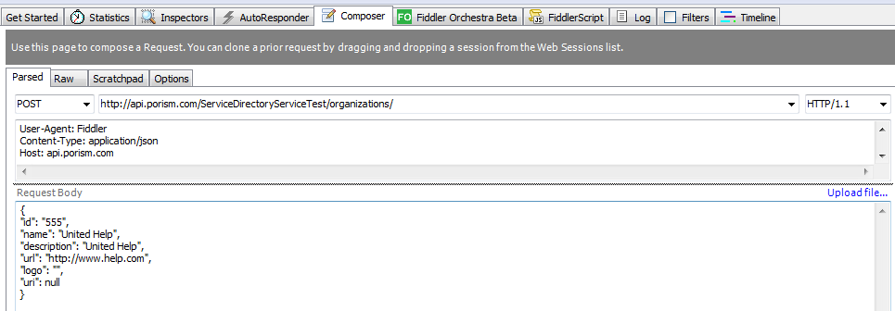
Sample POST request for an organization

Appendix F - Acknowledgements - Who we consulted
Thanks to people from these organisations who we have consulted and shared our work with:
- 87 Percent
- Ayup
- Blackburn with Darwen Borough Council
- Buckinghamshire County Council
- Department for Digital, Culture, Media & Sport (DCMS)
- Doc&Tee
- Elemental Software
- Elmbridge Borough Council
- Famiio
- Global Initiative
- Healthier London Partnership
- Hull City Council
- Lancashire Citizens Advice Bureau
- Lancashire & South Cumbria Integrated Care System
- Local Government Association (LGA)
- Ministry of Housing, Communities & Local Government (MHCLG) Local Digital
- North Yorkshire County Council
- OpenActive
- Open Referral lead - Greg Bloom
- OrbUniverse
- Public Consulting Group
- Rethink
- Sarapis
- Simply Connects Solutions
- Sirona Care and Health
- SiteKit
- South Gloucestershire Council
- Sports England
- VidaVida
- Wellaware

